VIETNAM NATIONAL UNIVERSITY HO CHI MINH CITY

INTERNATIONAL UNIVERSITY



**WEB APPLICATION DEVELOPMENT**

**PROJECT**

By:

NGUYEN QUOC DAT – ITITIU21171

NGUYEN SY THUY – ITITIU21326

PHAM TRUNG DUNG – ITITIU21007

SCHOOL OF COMPUTER SCIENCE AND ENGINEERING

OUTLINES

**I.** **INTRODUCTION** 3

**1.** **ABOUT US** 3

**2.** **THE PRODUCT’S INFORMATION** 3

**3.** **DEVELOPMENT ENVIRONMENT** 3

**II.** **REQUIREMENT ANALYSIS AND DESIGN** 5

**1.** **REQUIREMENT ANALYSIS** 5

**A.** **FUNCTIONAL REQUIREMENTS** 5

**B.** **NON-FUNCTIONAL REQUIREMENTS** 9

**2.** **DESIGN** 10

**A.** **ERD DIAGRAM** 10

**B.** **RELATIONAL SCHEMA DIAGRAM** 11

**C.** **CLASS-DIAGRAM** 11

**D.** **USER CASE DIAGRAM** 14

**E.** **API** 15

**III.** **IMPLEMENTATION** 16

**IV.** **DISCUSSION AND CONCLUSION** 40

**V.** **REFFERENCES** 41

1. **INTRODUCTION**
2. **ABOUT US**

In this section, we introduce the nature of our project software development team, the "car selling project". We delve into the foundational aspects of our endeavor – a car selling website project – and highlight the challenges encountered throughout the project's development journey. We joined hands to realize a platform project for trading cars. Our collaboration harnesses our shared skills and vision, creating a user-centric digital space for buying and selling cars.

1. **THE PRODUCT’S INFORMATION**

In today’s increasingly modern era, cars are everywhere, but the variety of showrooms available for sale often leaves users overwhelmed and consumers have to carefully consider price and reputation to avoid being scammed. The challenge lies in finding a balance between price and user-friendly features that easily cater to a diverse audience around the world. The solution we propose is a car exchange website called “car selling”, designed with meticulous attention to address these challenges. By providing a streamlined and intuitive user experience combined with powerful functionality, “car selling” aims to foster a favorable environment between sellers and buyers. This initiative is driven by our commitment to making it easier to choose the “companion” for every family’s purpose and to establish a global community where people can easily get the exact look they want with the type of vehicle they want.

1. **DEVELOPMENT ENVIRONMENT**

+ Front End: Using Nodejs: ReactJS, Embedded JavaScript

+ Back End: Implementing Servlets to handle server-side logic

+ Database: Employing MySQL for data storage and management

+ Architecture: Following the Model-View-Controller (MVC) for structuring code.

+ Version Control: Managing code with GitHub to track changes and collaborate. Link github: https://github.com/ITITIU21171/WebPrj.git

+ Communication: Using Discord for team meetings and discussions.

+ Task management: Keepiing track of work with Google sheet

+ Documentation: Using JSON to store raw data

1. **REQUIREMENT ANALYSIS AND DESIGN**

This section presents a customized requirements analysis and design framework for the development of the trading platform. It acts as a blueprint for the project implementation, specifying each feature along with the defined conditions, as well as the functional and non-functional requirements outlined by the client. During the development process, we will continuously update and improve future iterations, ensuring an accurate and comprehensive record of the project's progress.

1. **REQUIREMENT ANALYSIS**
2. **FUNCTIONAL REQUIREMENTS**

**Use case 1: Log in**

+ Product scope: Allows users to log into the system to perform their functions.

+ Main action:

|  |  |
| --- | --- |
| Actor: User | System |
| 1. Select the login function | 1.1 Display login screen |
| 2. Enter username and password | 2.1 Fail -> move to sub-action  2.2 Succesful -> display screen |
| 3. End of use case |  |

+ Sub action

|  |  |
| --- | --- |
| Actor: User | System |
| 1. Password checking | 1.1 Noticed that there is wrong username or password  1.2 Rre-display login screen  1.3 Return to step 2 in main action |
| 2. Change password  2.1 Click “change password” in login screen  2.2 Enter old password and enter new password, replay new password  2.3 Enter new password | 2.1 Display screen to change password  2.2.1 Check old password  2.2.2 Check if the new password and re-entered new password are the same  2.3 Display successful notification screen |

+ Precondition: User must have an account on the system

+ Post-condition: User succesfully logged in

**Use case 2: Manage accounts**

+ Product scope: Allows admin to manage customer accounts

+ Main action:

|  |  |
| --- | --- |
| User: Admin | System |
| 1. Click “manage account” to request | 1.1 Show form “manage account” |
| 2. Action (more details, lock, open account) | 2.1 Return the corresponding operation result |

+ Precondition: Already have an admin account

+ Post-condition: Manage all accounts

**Use case 3: Manage cars**

+ Product scope: Allows admin to manage cars in website

+ Main action:

|  |  |
| --- | --- |
| User: Admin | System |
| 1.1 Send a car management request  1.2 Choose “add product”  1.3 Add information of car  1.4 Save new car | 1.1 Show manage form  1.2 Show add product form  1.3 Send information of car and check information  1.4 Send notice back |
| 2.1 Send a car management request  2.2 Choose “Update product”  2.3 Change information of car  2.4 Update information of car | 2.1 Show manage form  2.2 Show update product form  2.3 Send information of car and check information  2.4 Send notice back |
| 3.1 Send a car management request  3.2 Choose “delete car”  3.3 Update “manage car” | 3.1 Show manage form  3.2 Confirm delete and check validity  3.3 Send notice and result back |

+ Precondition: Already have an admin account

+ Post-condition: Manage all cars

**Use case 4: Manage type of cars**

+ Product scope: Allows admin to manage types of all cars

+ Main action:

|  |  |
| --- | --- |
| User: Admin | System |
| 1.1 Send a type of car management request  1.2 Choose “add type of product”  1.3 Add information of type  1.4 Save new type | 1.1 Show manage form  1.2 Show add type of product form  1.3 Send information of type and check information  1.4 Send notice back |
| 2.1 Send a type of car management request  2.2 Choose “Update type of product”  2.3 Change information of type  2.4 Update information of type of car | 2.1 Show manage form  2.2 Show update type of product form  2.3 Send information of type and check information  2.4 Send notice back |
| 3.1 Send a type of car management request  3.2 Choose “delete type of product”  3.3 Update “manage type of car” | 3.1 Show manage form  3.2 Confirm delete and check validity  3.3 Send notice and result back |

+ Precondition: Already have an admin account

+ Post-condition: Manage all types of car

**Use case 5: Manage origin of products**

+ Product scope: Allows admin to manage origin of cars.

+ Main action:

|  |  |
| --- | --- |
| User: Admin | System |
| 1.1 Send a origin management request  1.2 Choose “add origin”  1.3 Add information of origin  1.4 Save new type | 1.1 Show origin form  1.2 Show add origin form  1.3 Send information of origin and check validity  1.4 Send notice back |
| 2.1 Send a origin management request  2.2 Choose “Update origin”  2.3 Change information of origin  2.4 Update information of origin | 2.1 Show manage form  2.2 Show update origin form  2.3 Send information of origin and check information  2.4 Send notice back |
| 3.1 Send a origin management request  3.2 Choose “delete origin”  3.3 Update “manage origin” | 3.1 Show manage form  3.2 Confirm delete and check validity  3.3 Send notice and result back |

+ Precondition: Already have an admin account

+ Post-condition: Manage origin of cars

**Use case 6: Manage bills**

+ Product scope: Allows admin to manage bills

+ Main action:

|  |  |
| --- | --- |
| User: Admin | System |
| 1.1 Send manage bill request  1.2 Choose see more details  1.3 Choose back | 1.1 Show bill form  1.2.1 Check id of bill  1.2.2 Send back result  1.2.3 Send bacl notice  1.3 Return to home page |
| 2.1 Send manage bill request  2.2 Click received | 2.1 Show bill form  2.2 Update the bill |
| 3.1 Send managest bill request  3.2 Click cancelled | 3.1 Show bill form  3.2 Update the bill |

+ Precondition: Already have an admin account

+ Post-condition: Manage all bills

**Use case 7: Revenue statistics**

+ Product scope: Allows admin to compile revenue statistics

+ Main action:

|  |  |
| --- | --- |
| User: Admin | System |
| 1.1. Send a request for statistical management  1.2 Statistics of received orders  1.3 Choose time | 1.1 display statistics form  1.2 request time information  1.3.1 Check information  1.3.2 Send back result |
| 2.1. Send a request for statistical management  2.2 Statistics of cancelled orders  2.3 Choose time | 2.1 display statistics form  2.2 request time information  2.3.1 Check information  2.3.2 Send back result |
| 3.1. Send a request for statistical management  3.2 Statistics of best selling orders  3.3 Choose time | 3.1 display statistics form  3.2 request time information  3.3.1 Check information  3.3.2 Send back result |

+ Precondition: Already have an admin account

+ Post-condition: Revenue Analysis

1. **NON-FUNCTIONAL REQUIREMENTS**

**1. Usability requirements:**

+ It is crucial to guarantee that all software components operate accurately and efficiently.

+ The hosting environment must hold an active license to manage incoming requests effectively.

+ A designated administrator should oversee regular software updates and actively monitor for system errors.

**2. Usability Requirements**:

+ Structured and straightforward to understand.

+ Clear and informative.

+ User-friendly, enabling seamless learning and navigation.

+ Allows users to accomplish tasks effortlessly and error-free.

**3. Humanity Requirements:**

+ Detailed documentation is provided to ensure users can fully comprehend the system through thorough reading.

+ The graphical user interface (GUI) is designed intuitively to facilitate easy learning and quick user adaptation.

+ Responsive interfaces are a critical aspect, enhancing the overall user experience.

**4. Maintainability Requirements:**

+ The system is built to support regular updates and modifications. Since users may have limited understanding of its internal processes, the development team must ensure the platform is user-friendly and straightforward for both users and maintenance staff.

+ The platform should offer intuitive features enabling users to easily update and manage information related to videos, channels, and viewer interactions.

+ The source code should be cleanly organized and thoroughly documented to improve readability and simplify future updates or debugging.

+ A well-defined and stable database architecture is essential to ensure a reliable foundation for maintenance and scalability.

1. **DESIGN**
2. **ERD DIAGRAM**

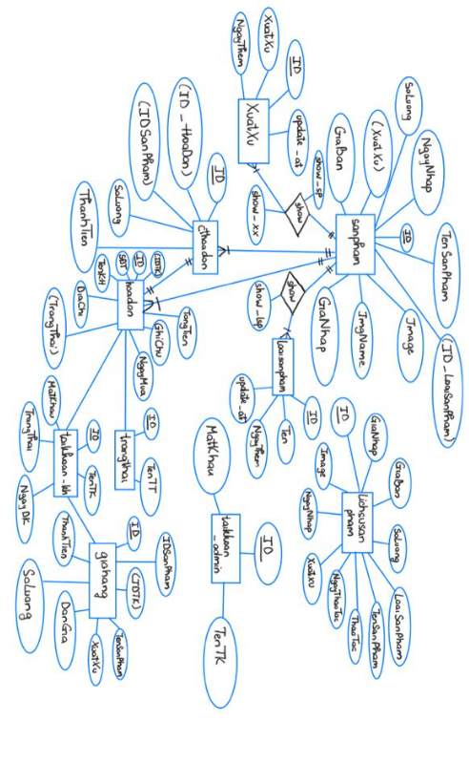

1. **RELATIONAL SCHEMA DIAGRAM**

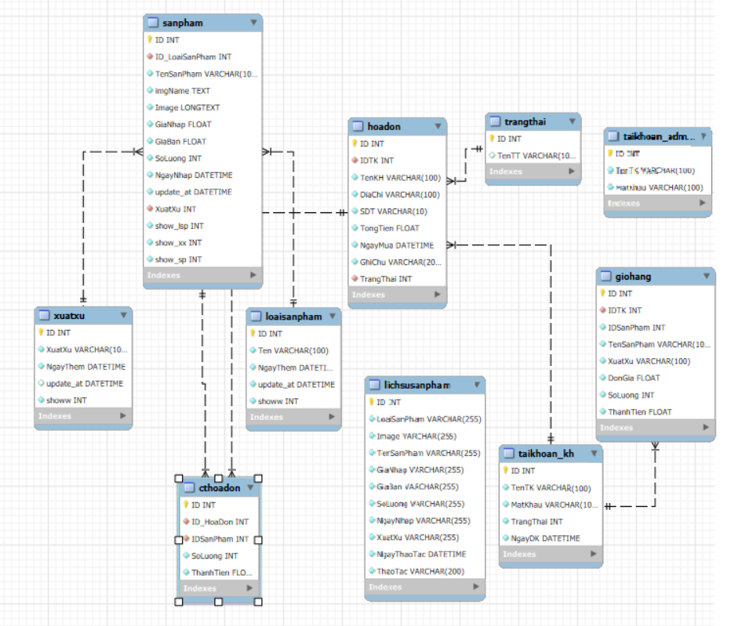

1. **CLASS-DIAGRAM**
2. **FRONT-END**

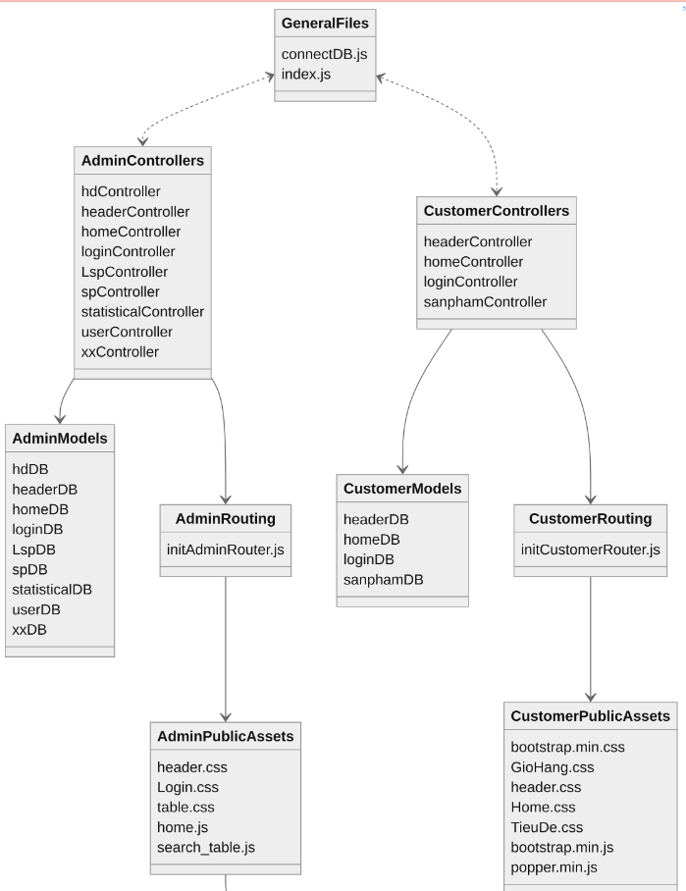

1. **BACK-END**

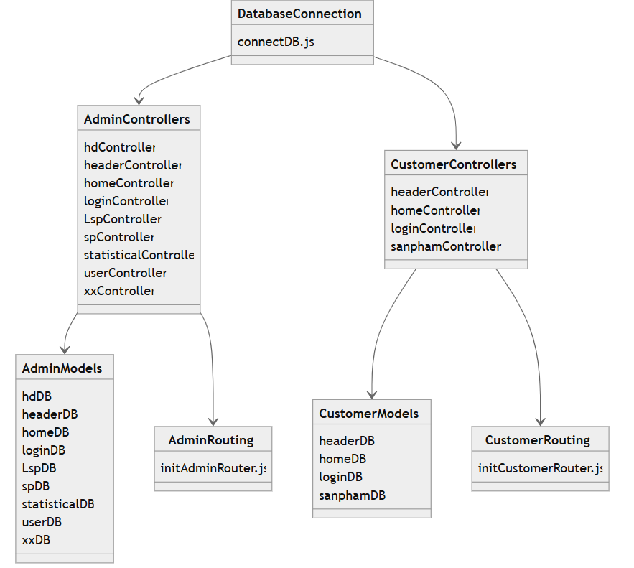

1. **LOGIC FLOW OF BACKEND API**

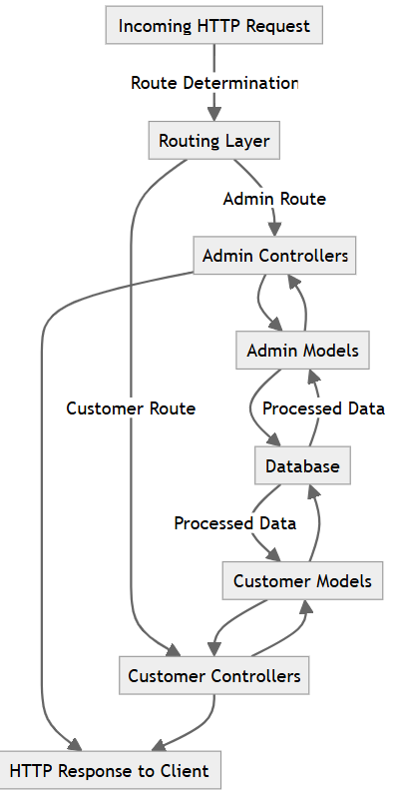

1. **USER CASE DIAGRAM**

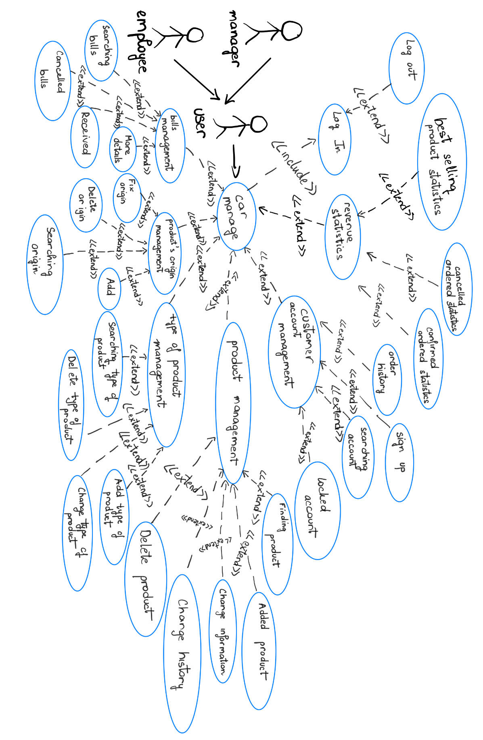

1. **API**
2. **FRONT-END:**
   * **/login**: Page for users to log in.
   * **/home**: Homepage displaying main content for users.
   * **/header**: Header section displayed on customer pages.
   * **/sanpham**: Page displaying products for customers.
   * **/admin**: Admin login page for administrative access.
3. **BACK-END:**
   * **/api/admin/hd**: Endpoint to manage admin header content.
   * **/api/admin/home**: Endpoint to manage admin home data.
   * **/api/admin/login**: Endpoint for admin login authentication.
   * **/api/admin/statistical**: Endpoint for retrieving statistical data.
   * **/api/admin/user**: Endpoint to manage user accounts.
   * **/api/admin/sp**: Endpoint for managing products.
   * **/api/customer/header**: Endpoint for retrieving customer page headers.
   * **/api/customer/home**: Endpoint for fetching customer home data.
   * **/api/customer/login**: Endpoint for customer login authentication.
   * **/api/customer/sanpham**: Endpoint for managing customer products.
4. **IMPLEMENTATION**

## 1. Users’ account

### 1.1 Account Management

1.1.1 Login to application

Step 1: Click Account icon

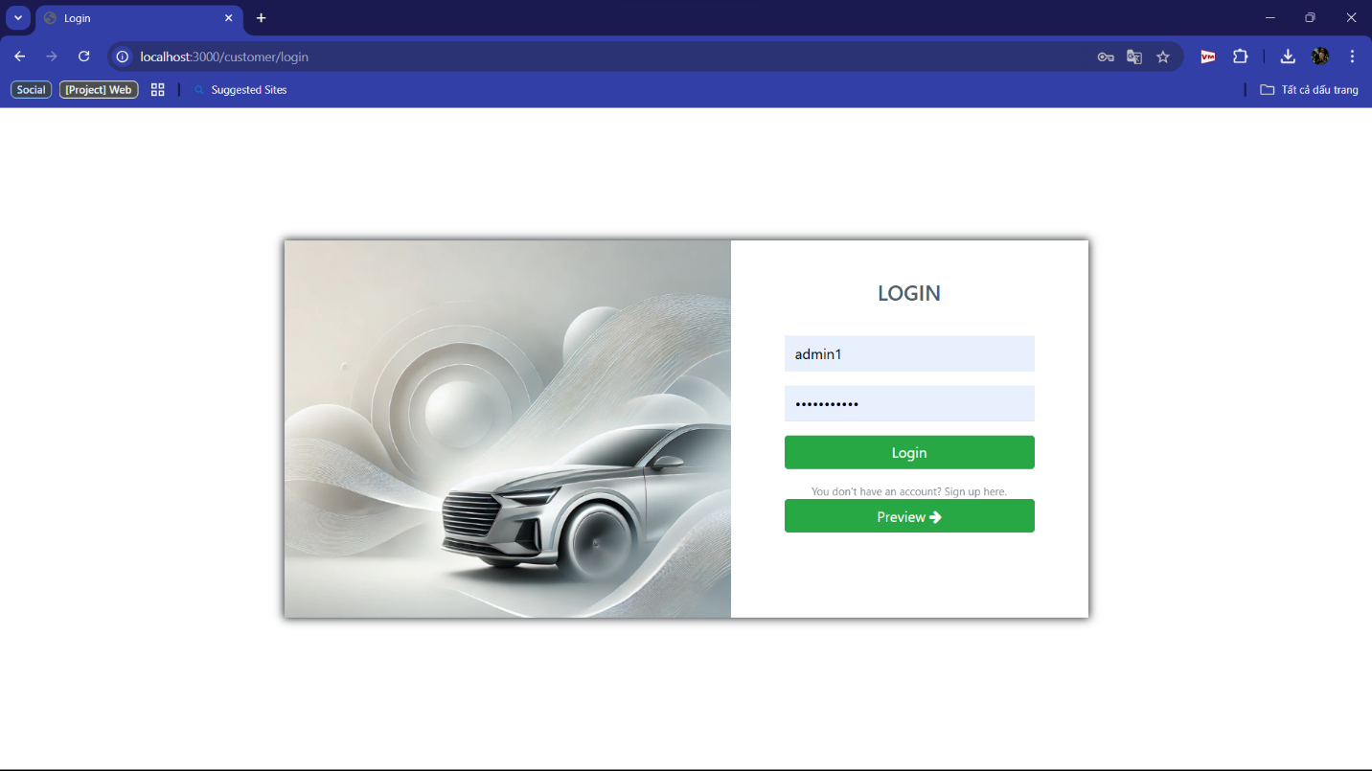

Step 2: Enter the user and password of your account. Then click “Login”, then the system will check if username and password is true it redirects to Home page. Otherwise, it will return the error message

+ True username and password:

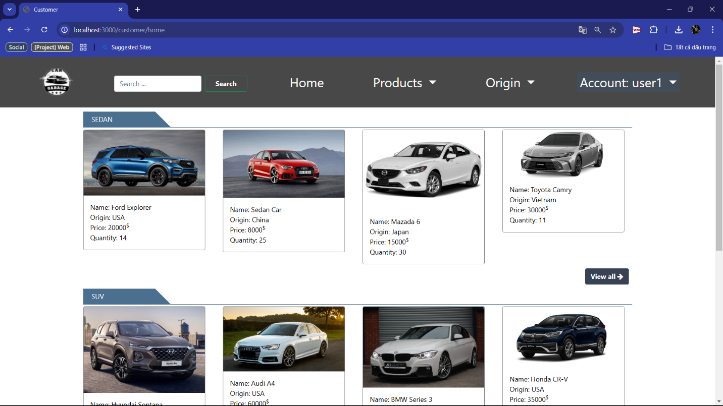

+ Wrong password or username:

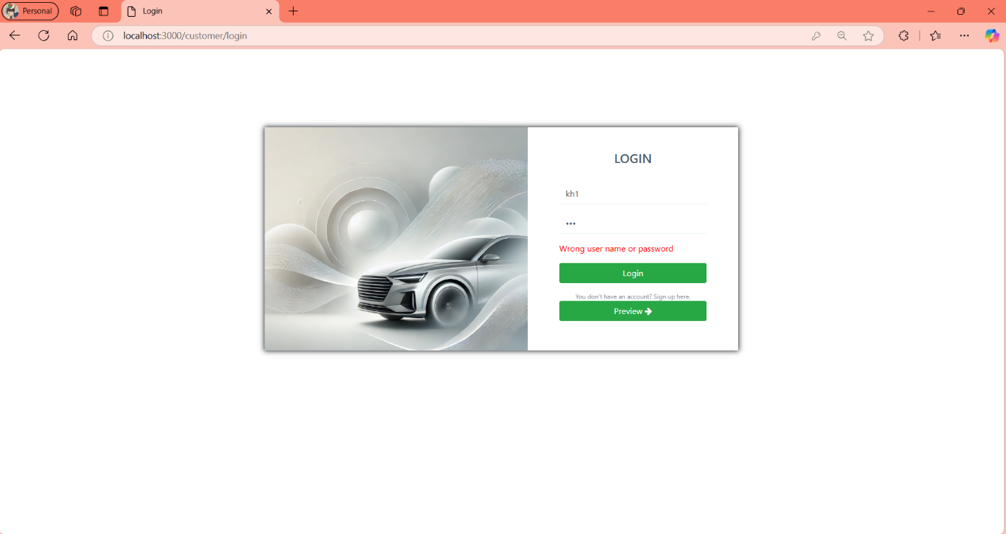

1.1.2 Register

Step 1: Click “Preview”



+ Step 2: Input username, password and re-password

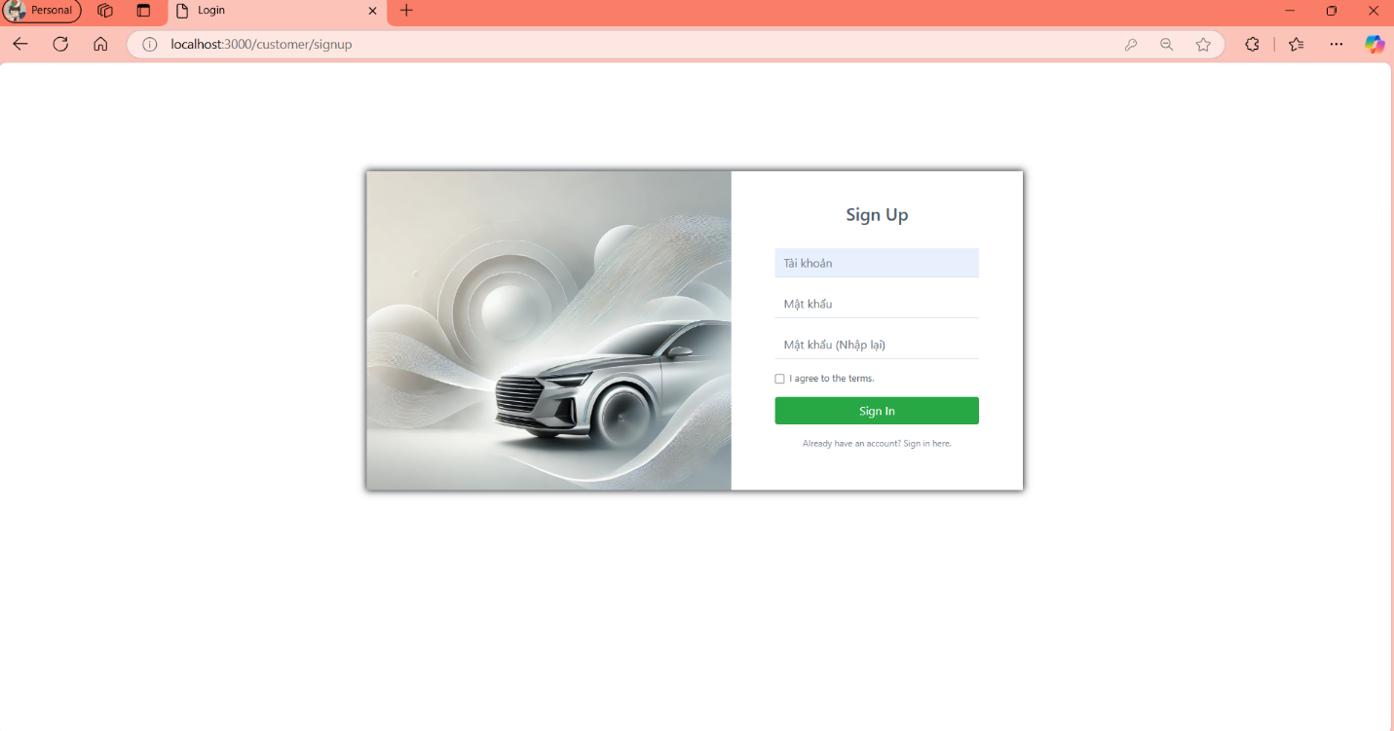

### 1.2. Home

1.2.1 Products

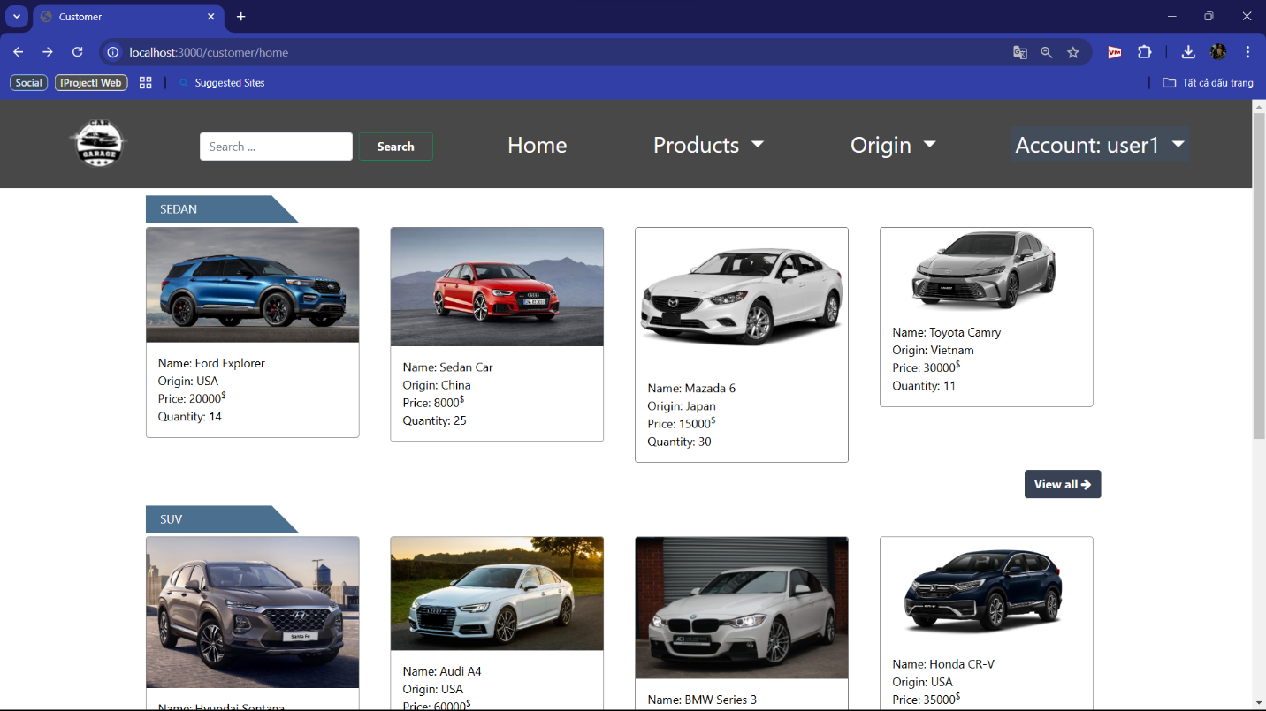

+ When you click “Products”, web will show all types of products, you click on the type you want and the web will show the one you choose.

Example: you choose “Sedan”

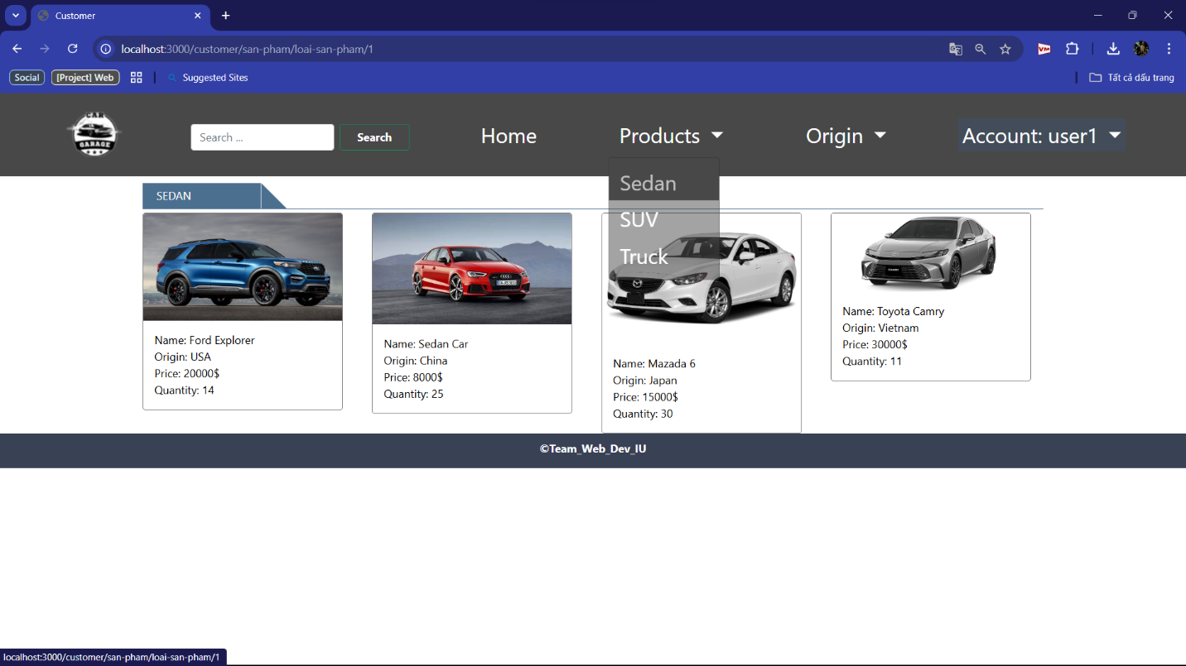

1.2.2 Origin

+ When you click “Origin”, web will show all origins of cars, you click on the type you want and the web will show the one you choose.

Example: you choose “USA”

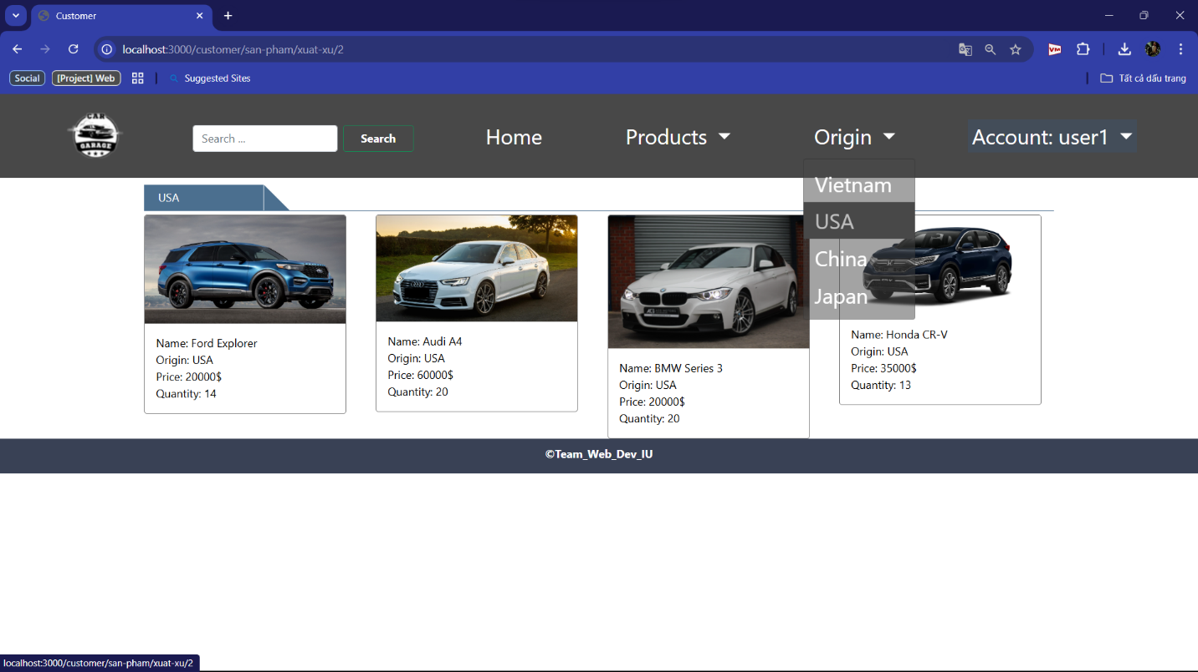

1.2.3 “Search” engine

+ You can search the car you want by type in “search” box

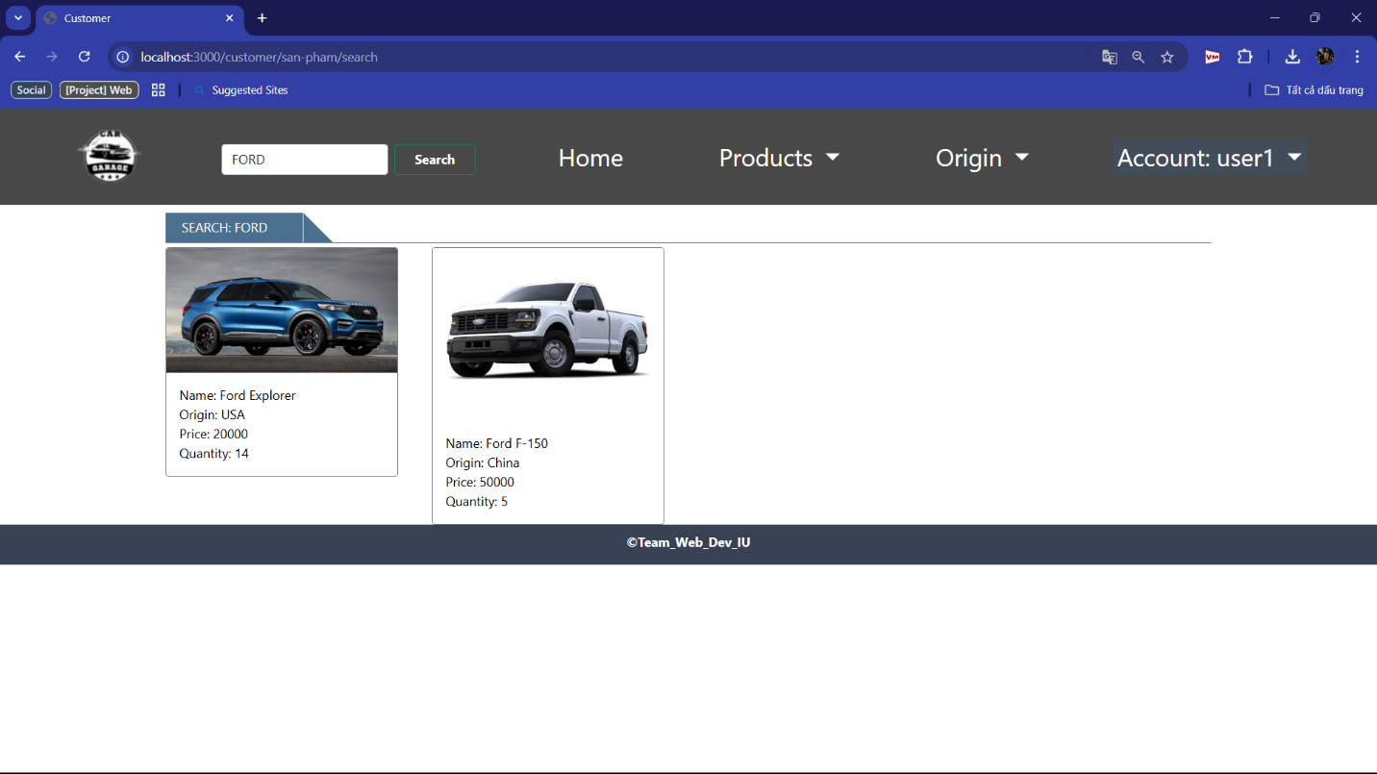

1.2.4 Account

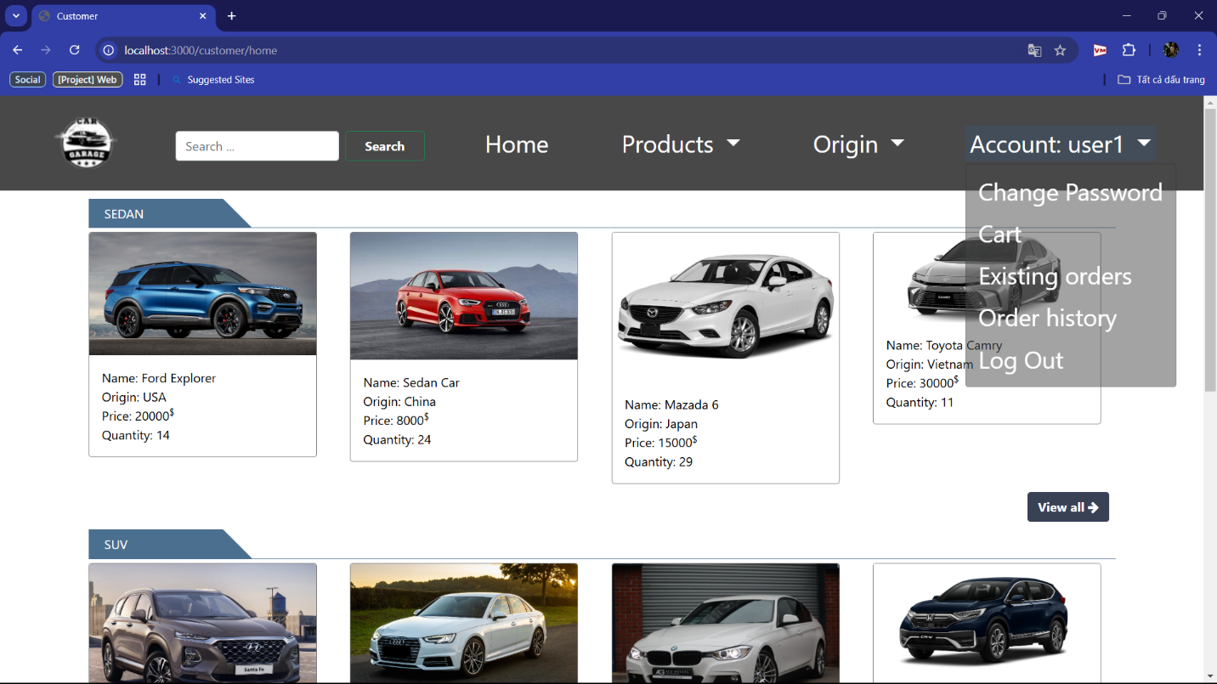

1.2.4.a Change password

Step 1: You click “Change password”

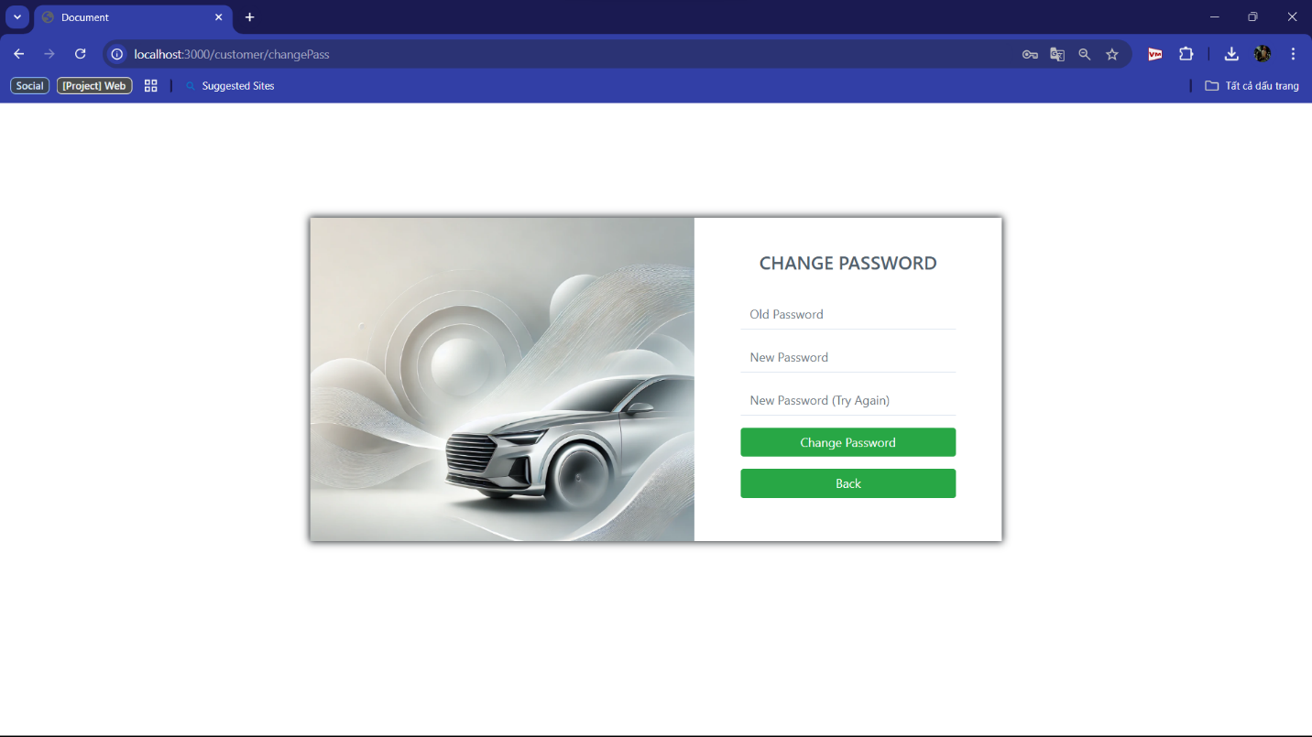

Step 2: Input old password, new password and re-new pasword. After that, click “Change password”. If you don’t want to change your password, click “Back”

1.2.4.b Cart

+ Step 1: Click to a car, you choose “Quantity to Buy” and click “Add to Cart”

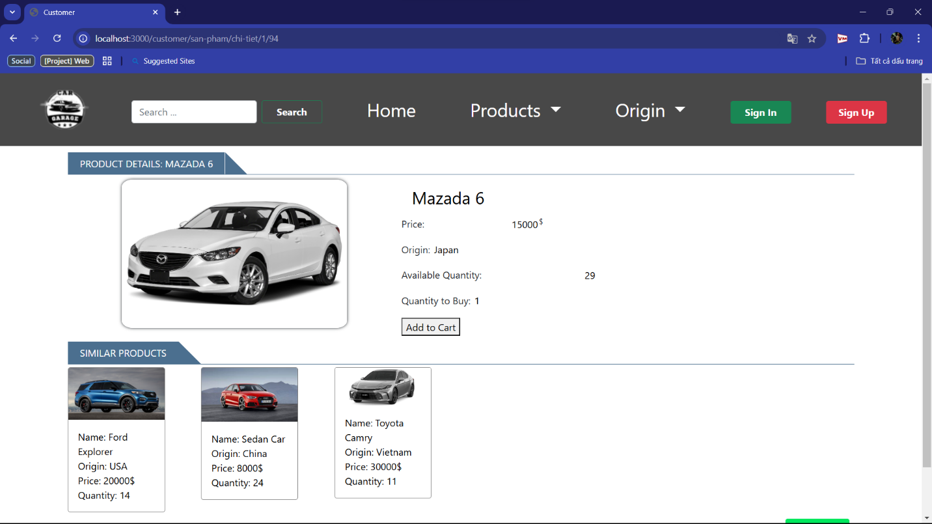

+ Step 2: Change to Cart Form

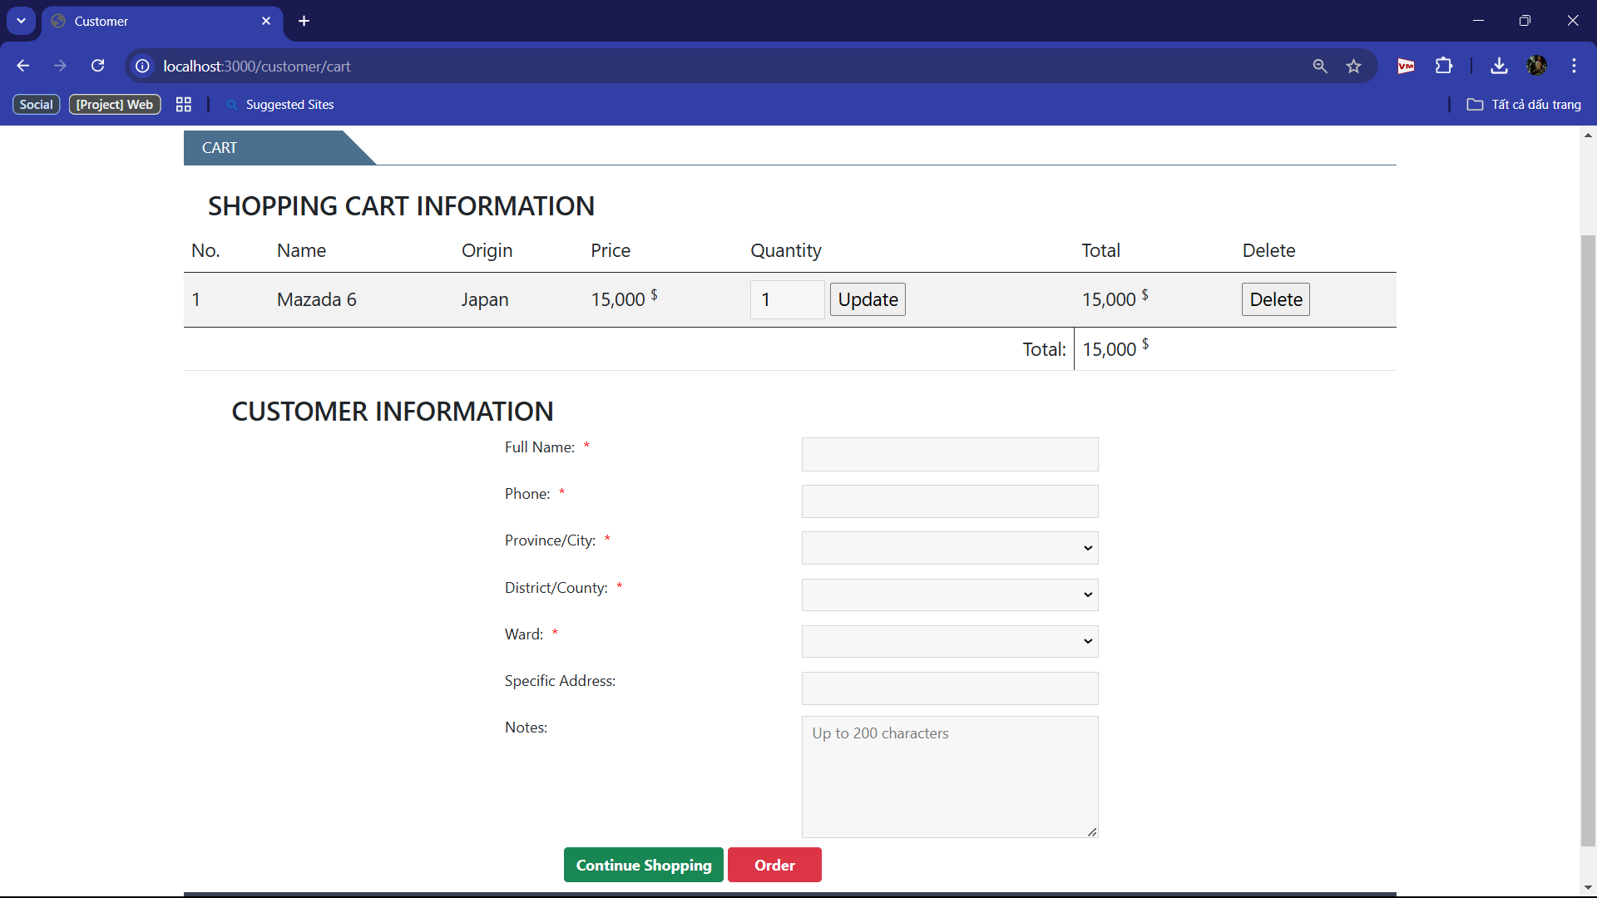

+ You can update the quantity of car or add more cars

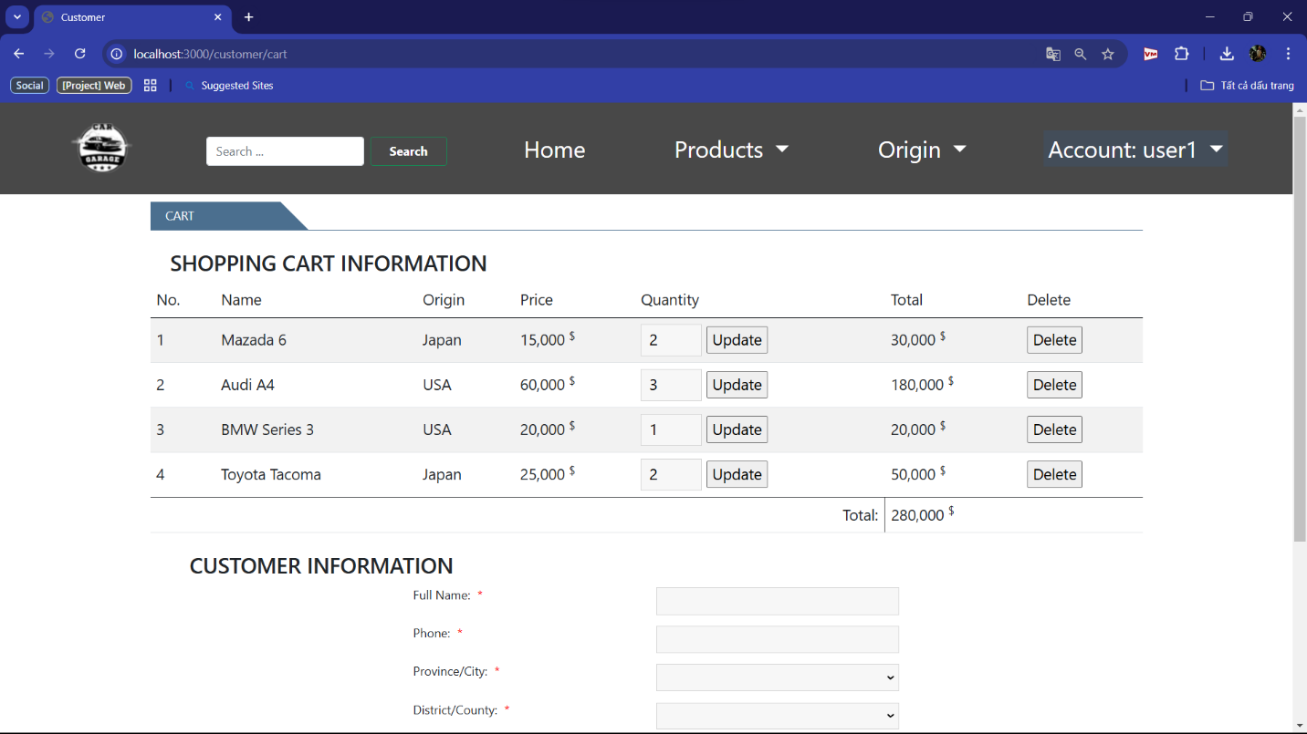

+ You can delete cars in cart, too

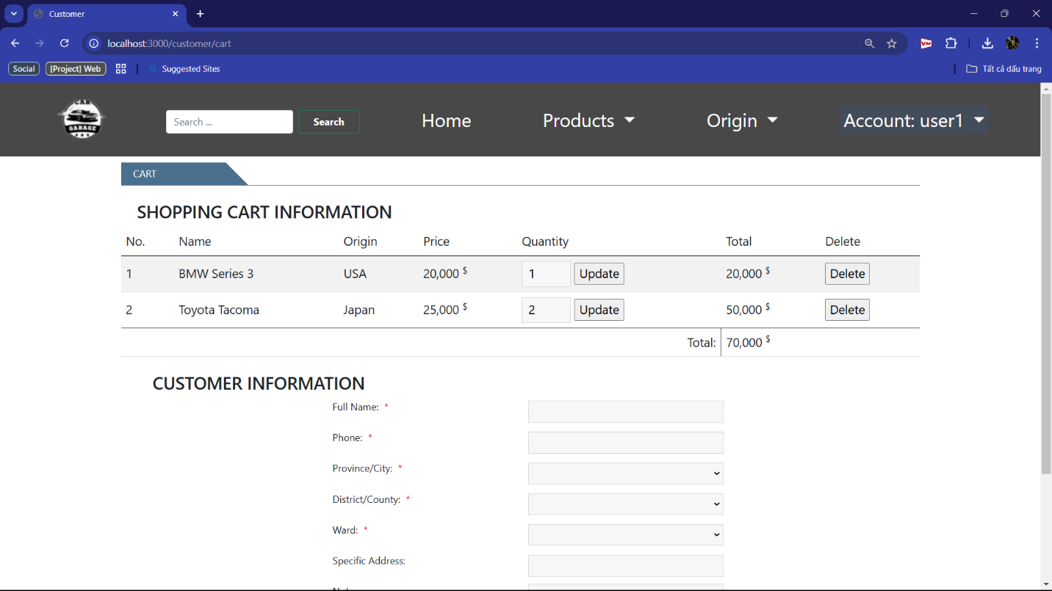

+ If you don’t fill information at “customer information”, the notice will show to remind you fill information

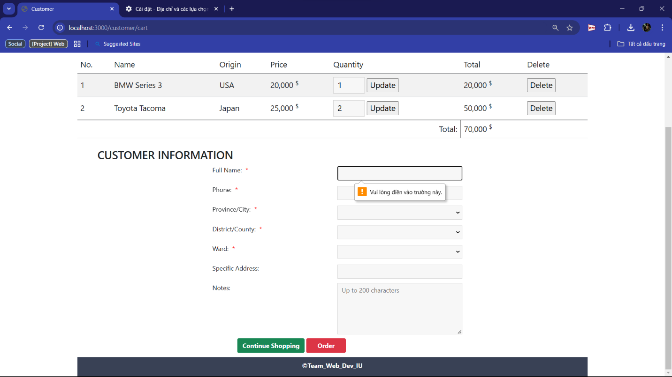

+ You can choose address

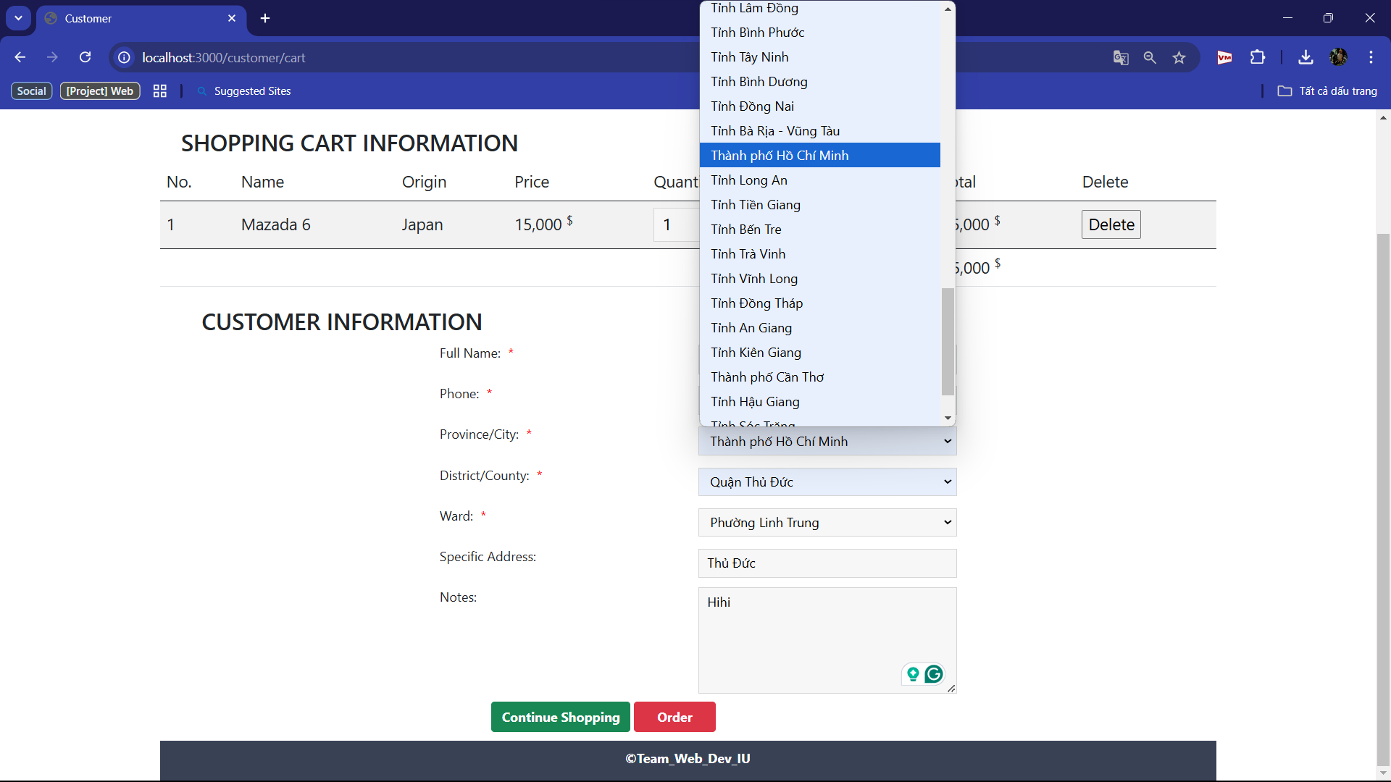

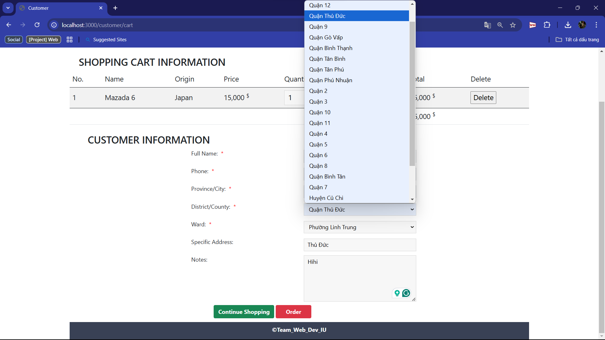

+ After that, you click “Order”

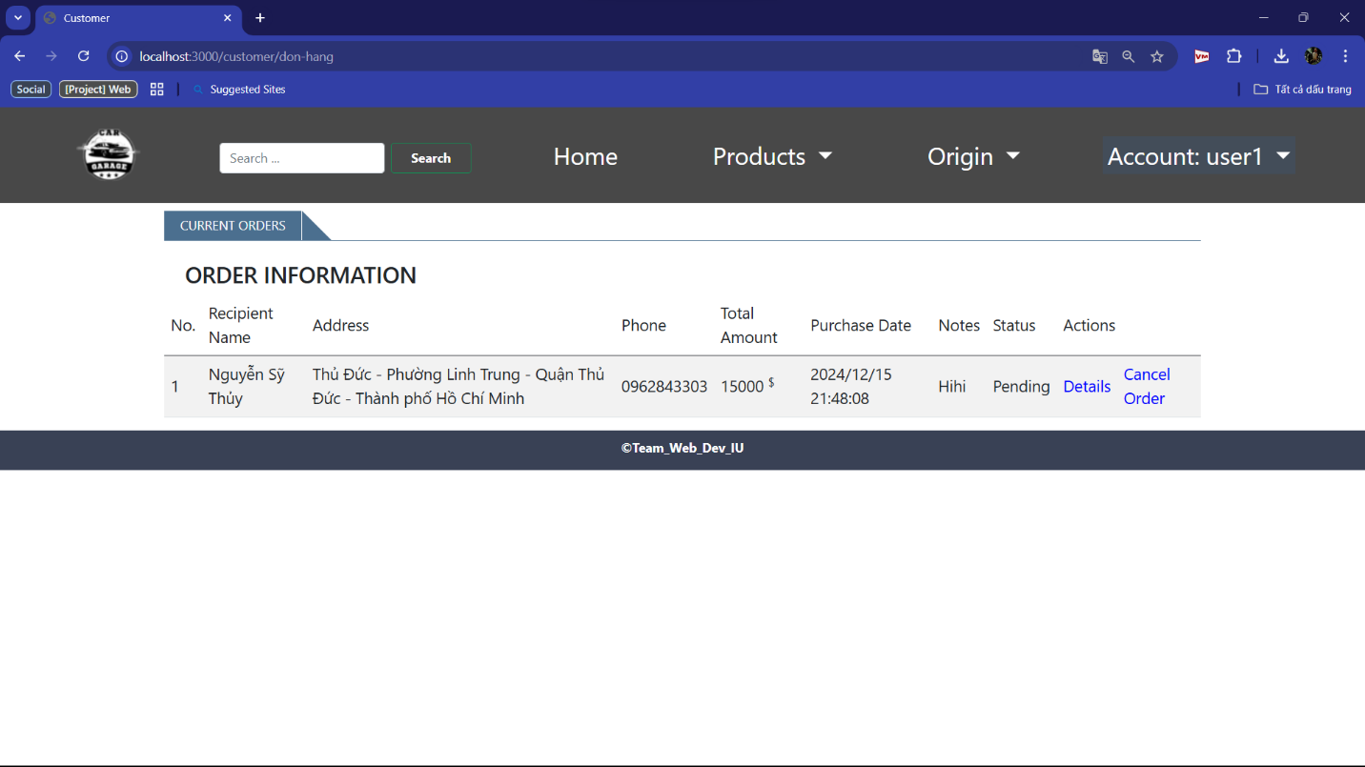

+ When you click “Cancel Order”, the Order will disappear. When you click “Details”

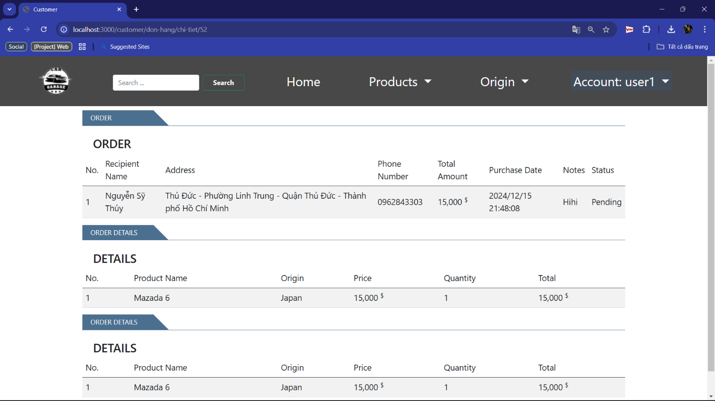

1.2.4.c Existing orders

+ When you click “existing orders”, the web will show your all waiting order

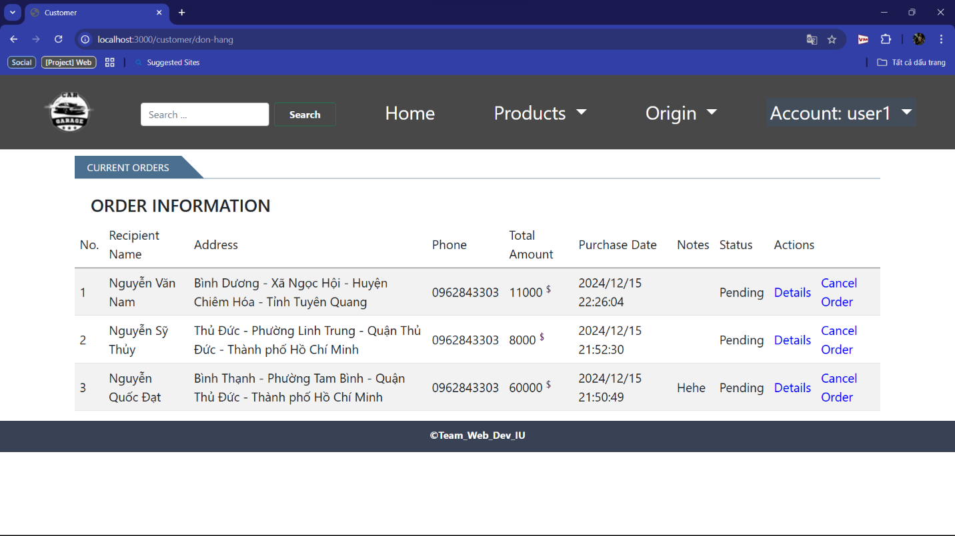

1.2.4.d Order history

+ When you click “order history”, the web will show all your cancelled/completed order

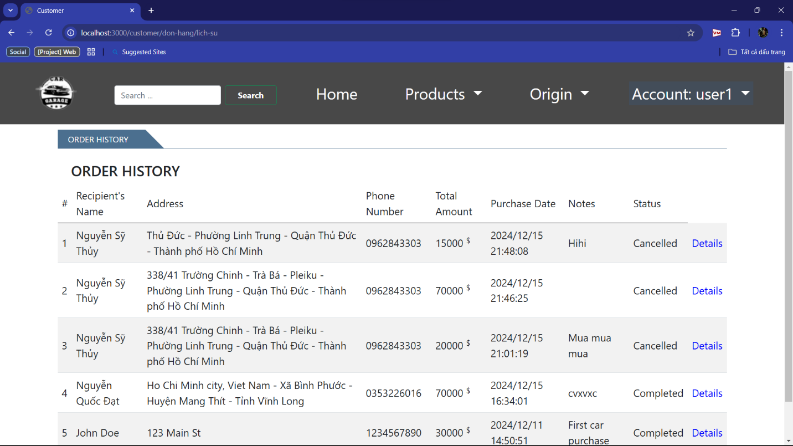

1.2.4.e Log out

+ When you “log out”, come back the log in screen



## 2. Admins’ Account

### 2.1 Login

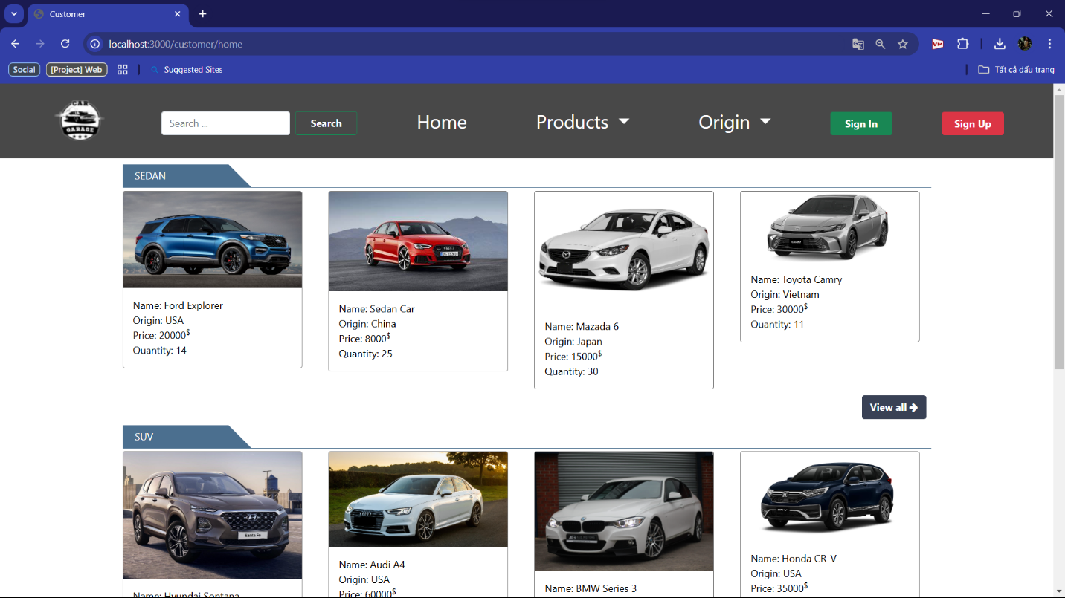

+ Step 1: If you click to the icon in the left corner of page, the login page will shown

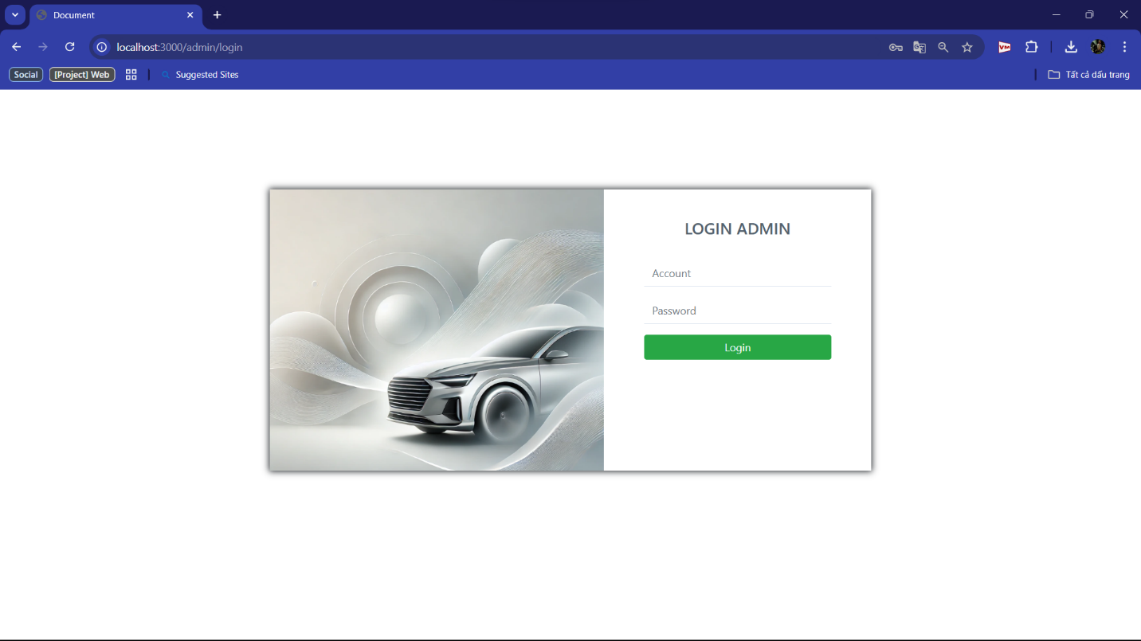

+ Step 2: When you fill username, and password, the web will show the login screen

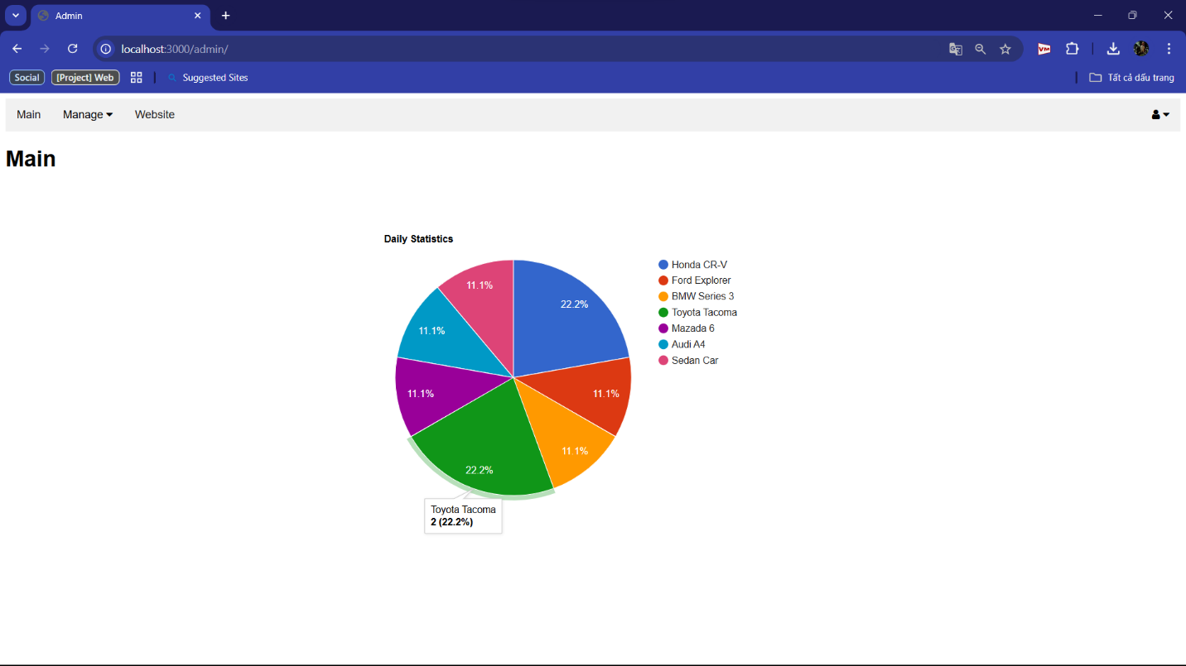

+ Login screen will show daily statistics

## 2.2 Admins’ manage

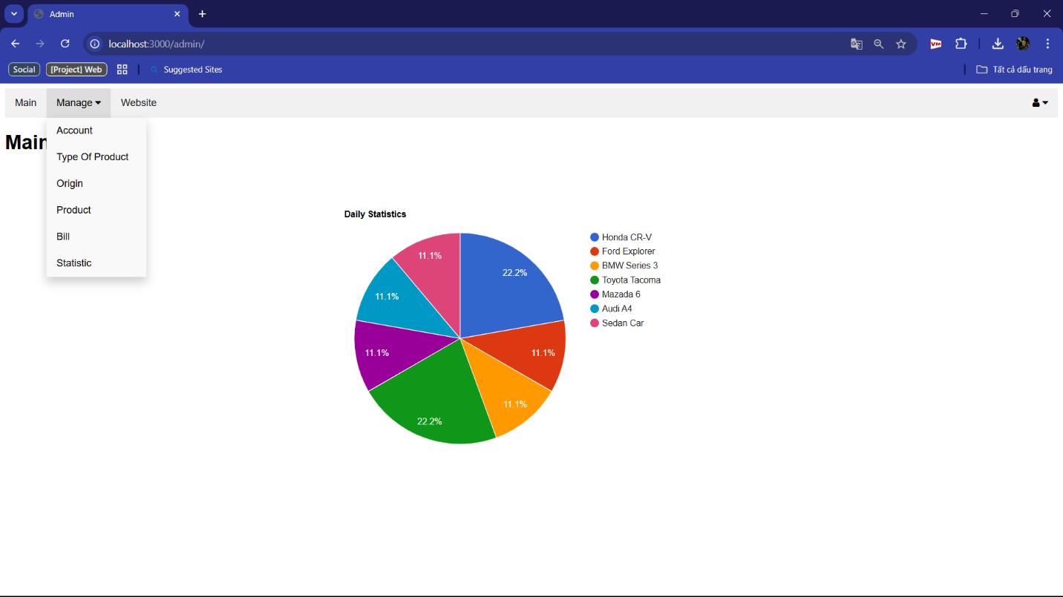

2.2.1 Account

+ When you click “Account”, the web show all account your web has

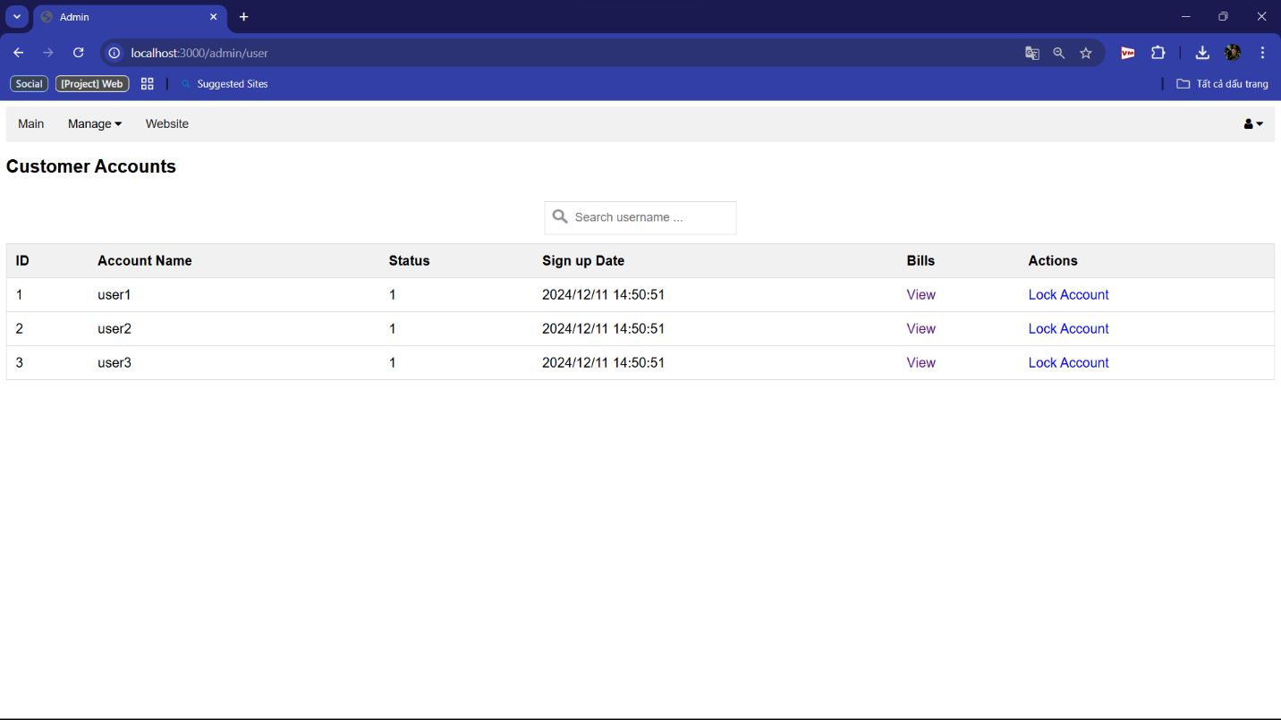

+ You can find Account by search

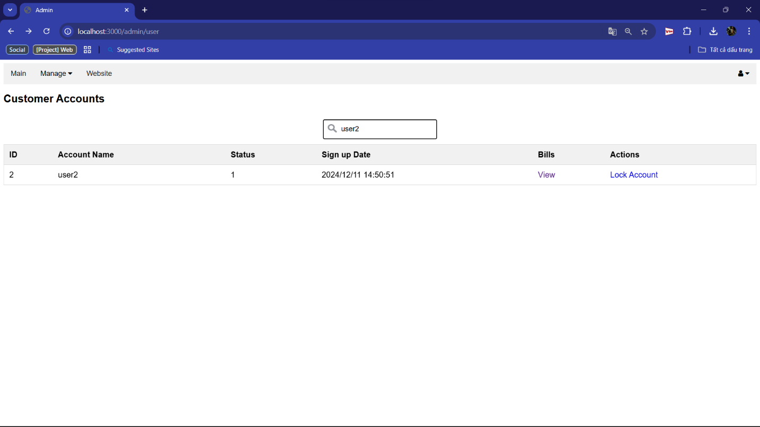

+ When you click “Views”, it will show all details as pending/ cancelled/ completed order

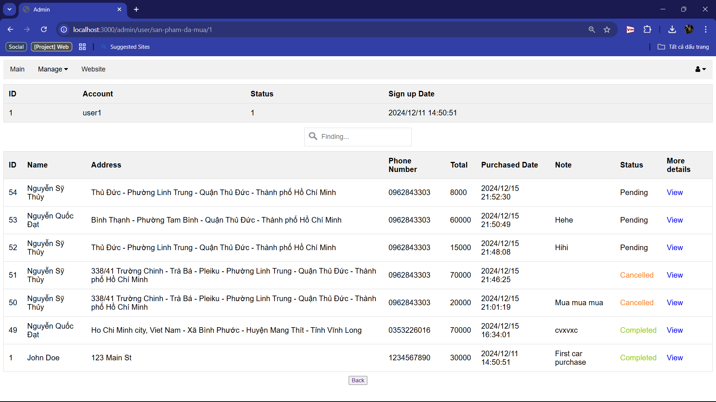

+ Click “view” to View more details in that bill

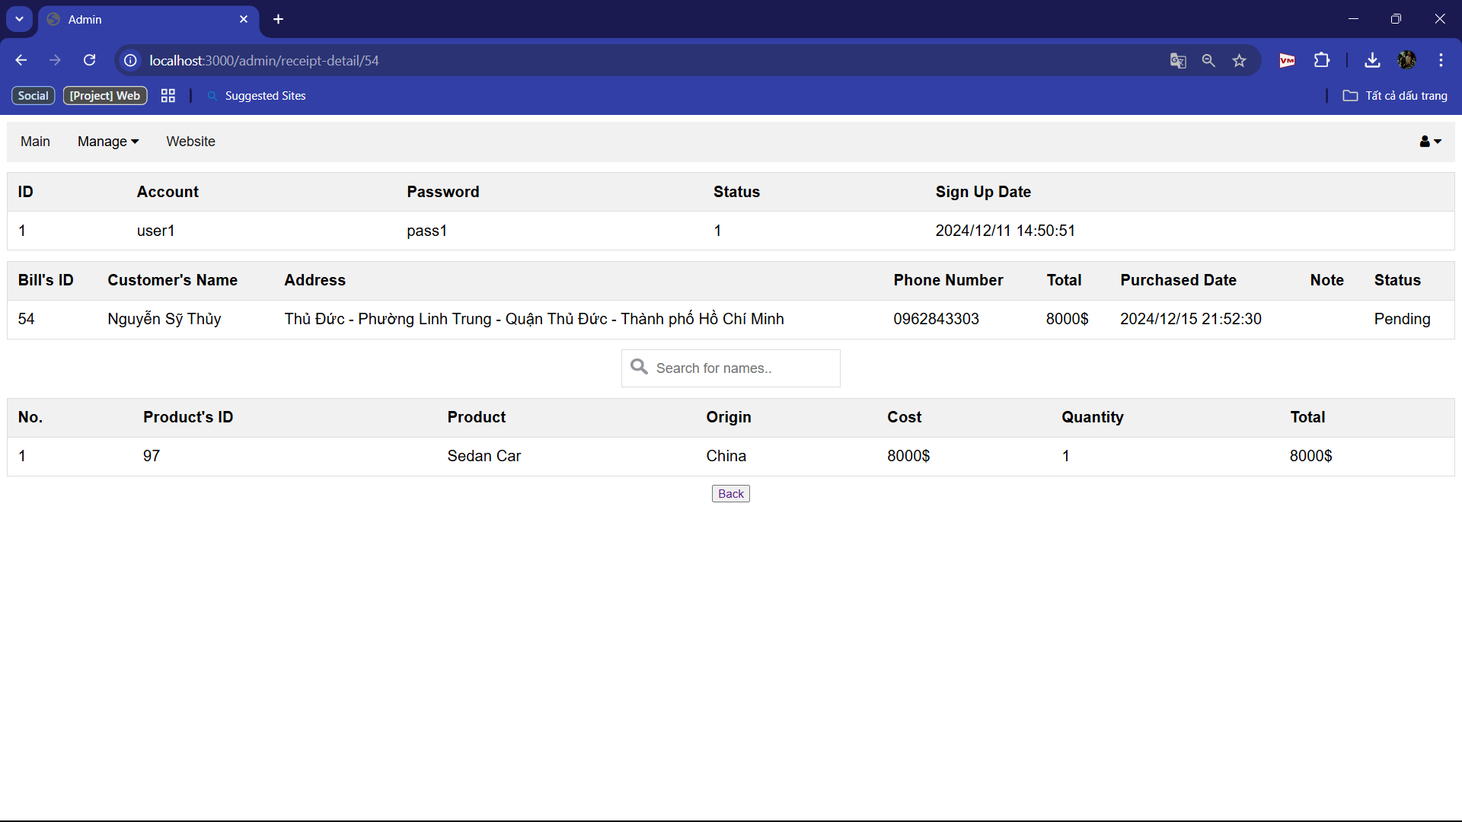

+ You can open or lock account

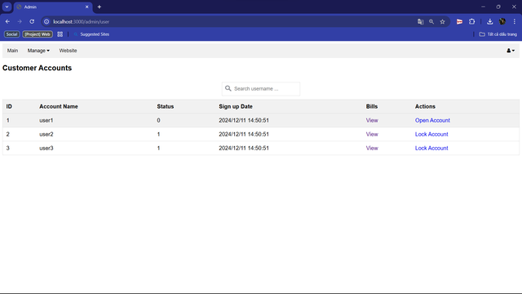

2.2.2 Manage type of products

+ When you click “Type of product”, it will show all types you have

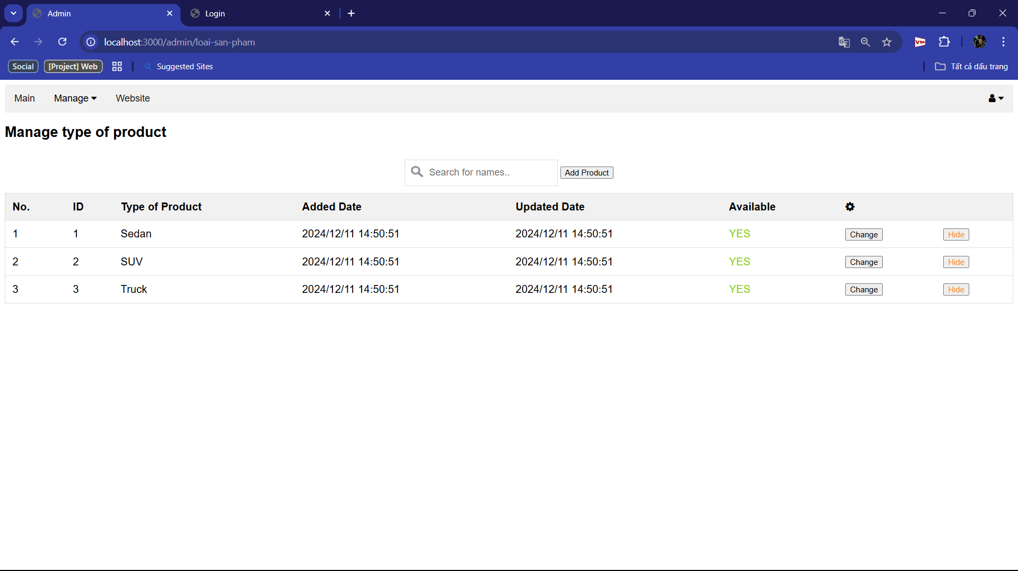

+ You can change the name of type of products when click “Change”

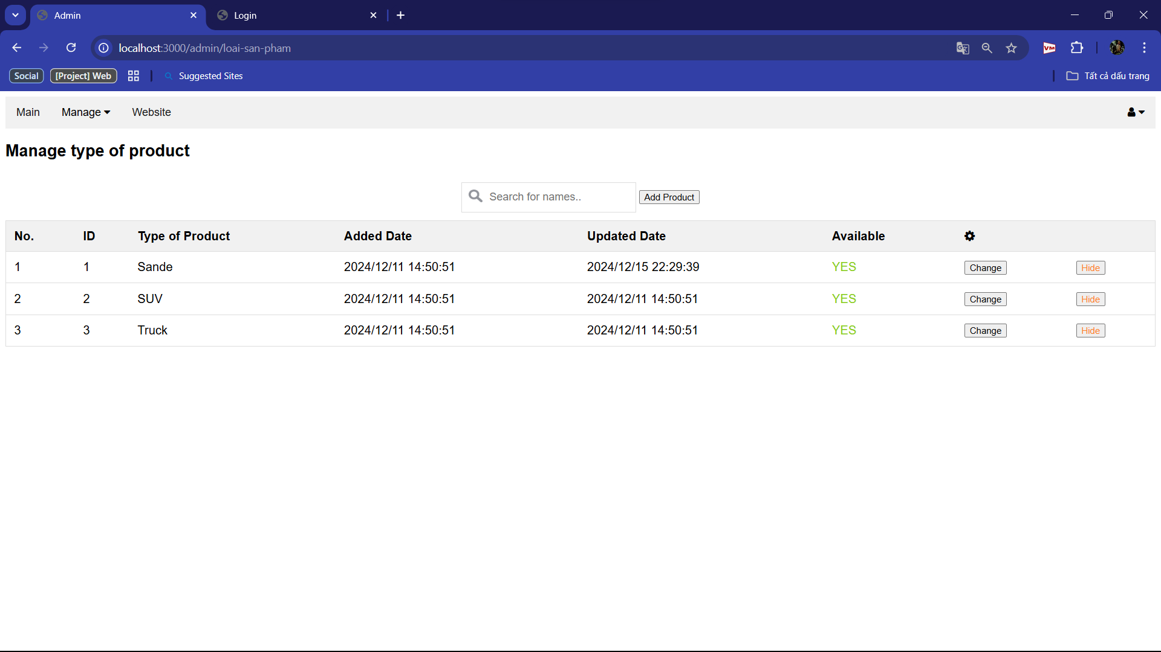

Then the name of products will be change in the customer’s web

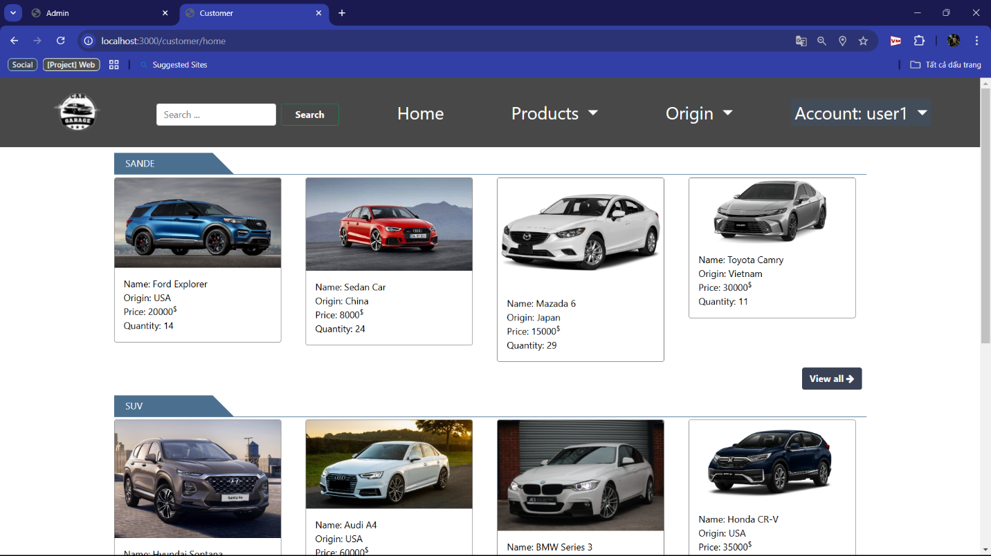

+ Hide/Show the type of products

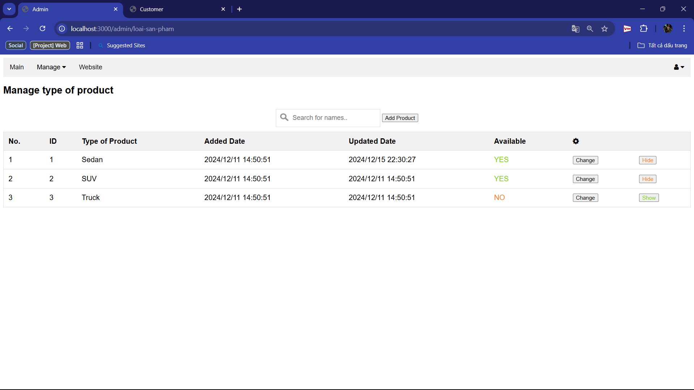

=> Then this type of product will be unavailable

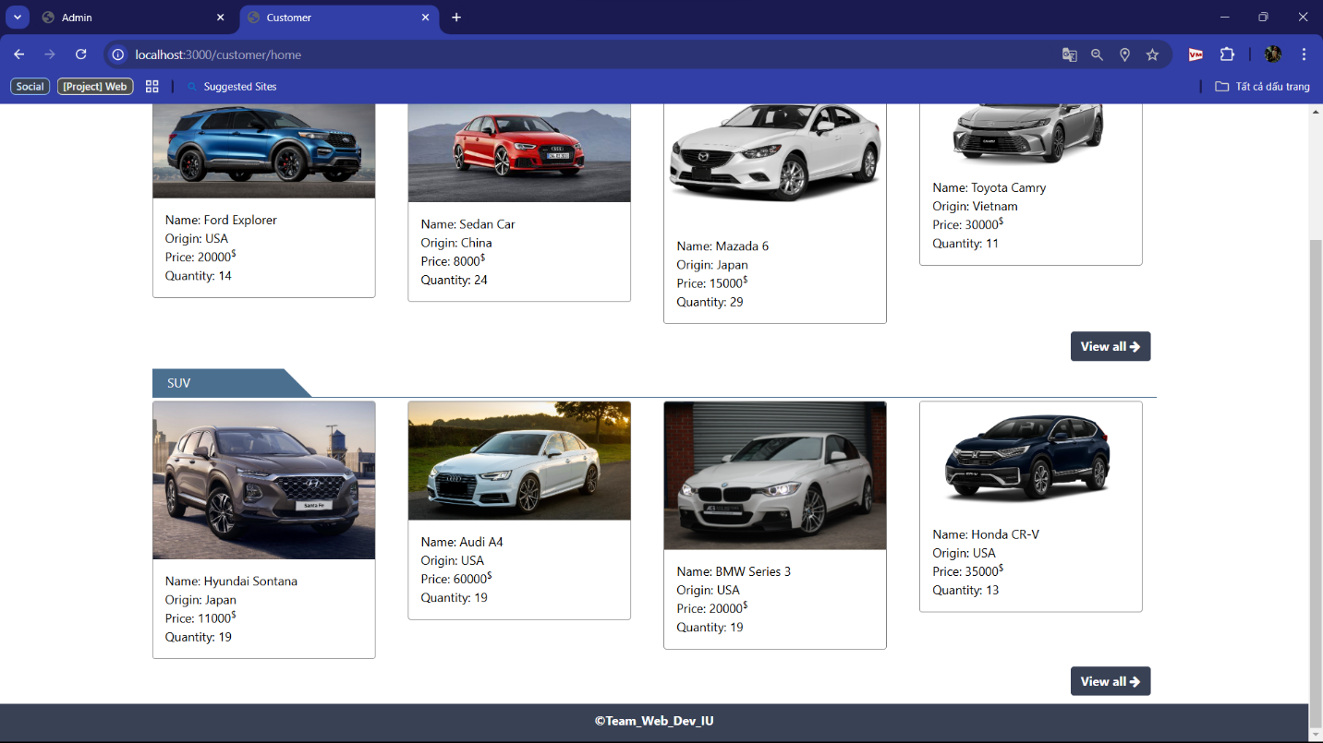

2.2.3 Manage origin of products

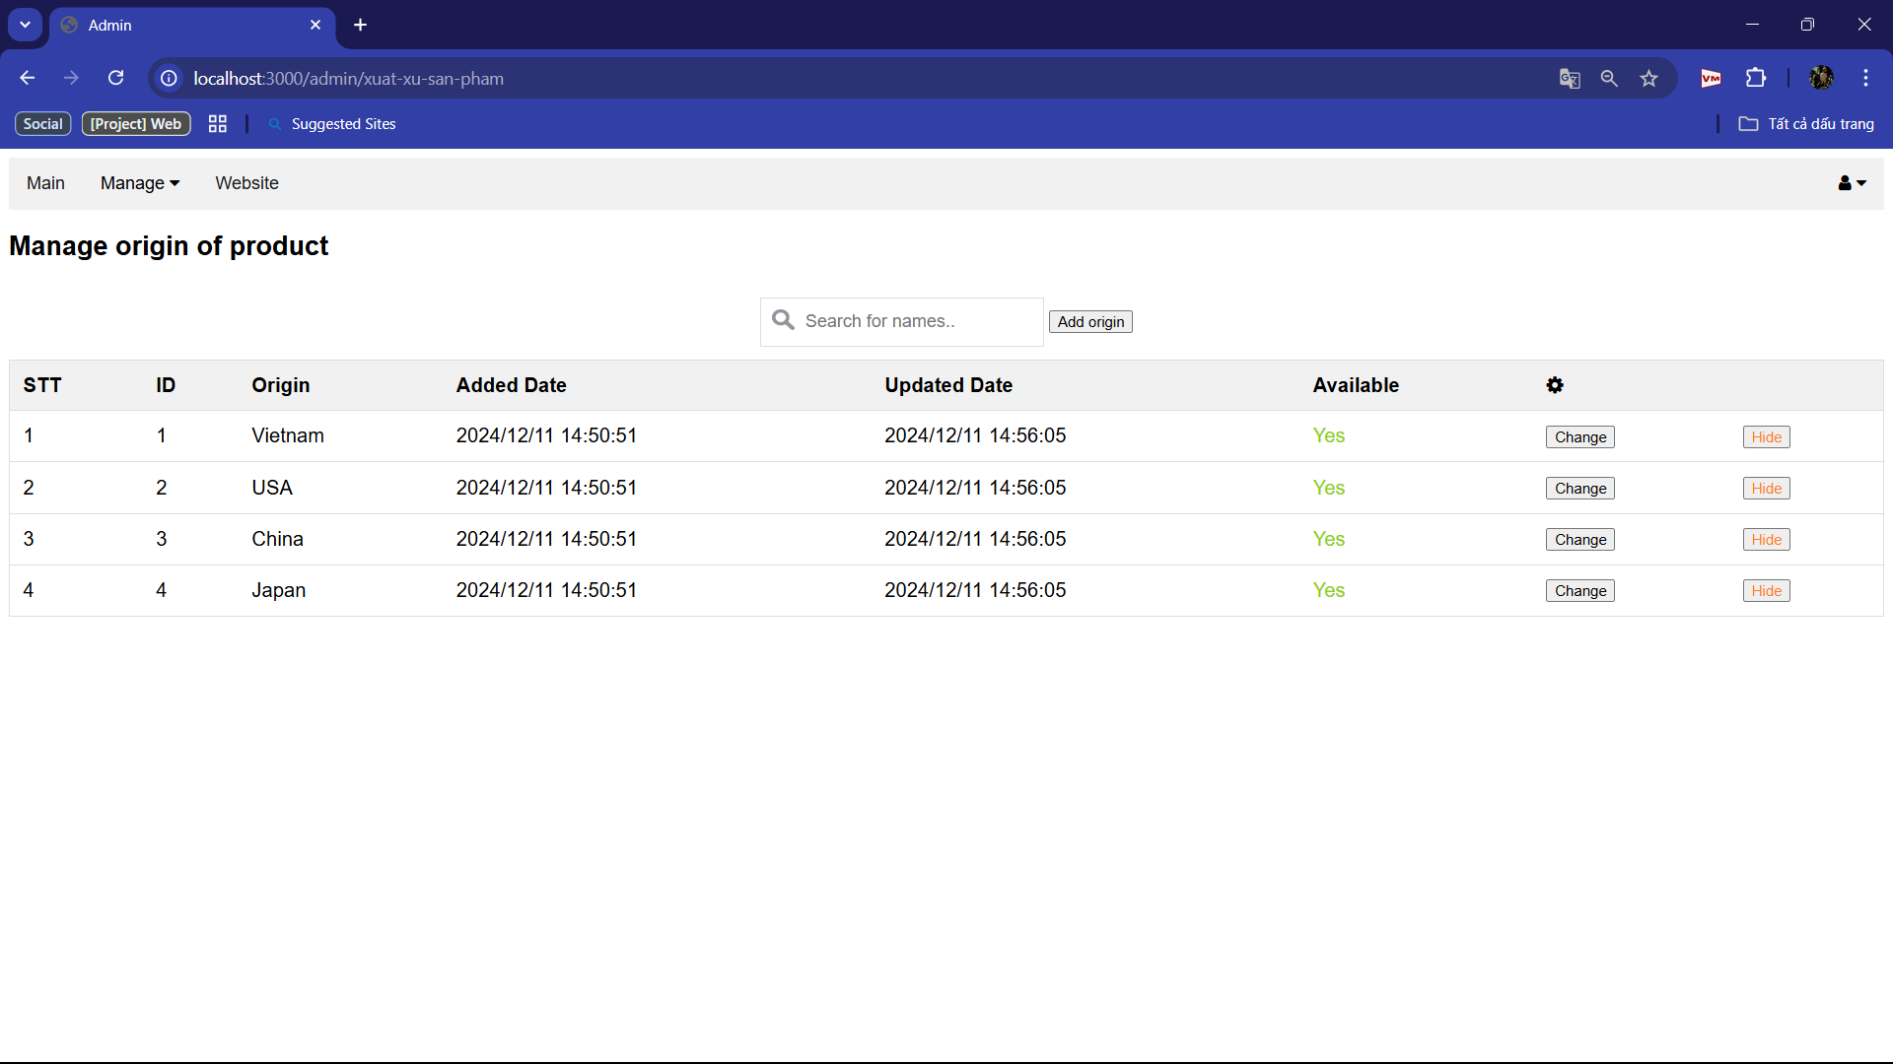

Manage products

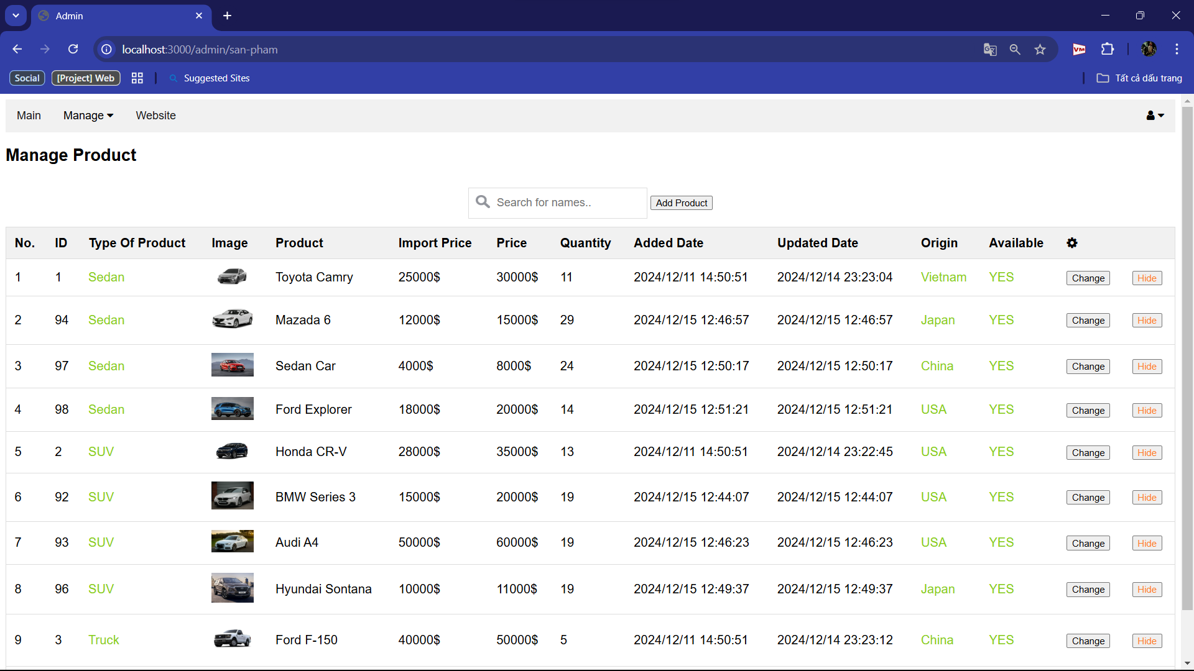

Add products

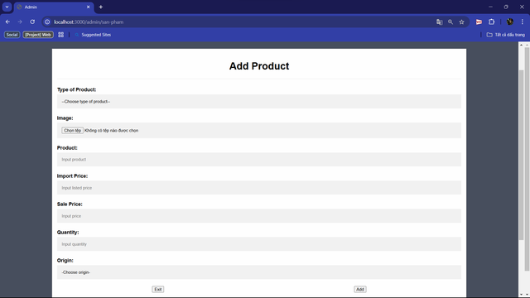

Change products

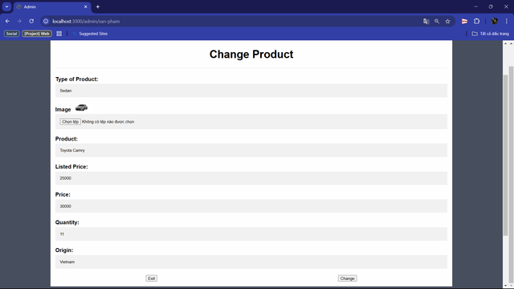

Bill management

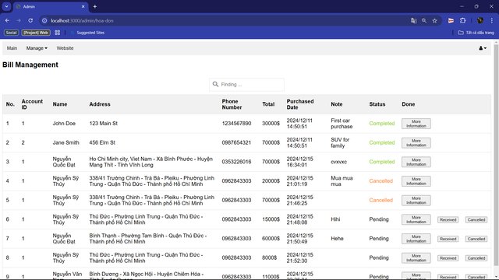

More Information in Bill

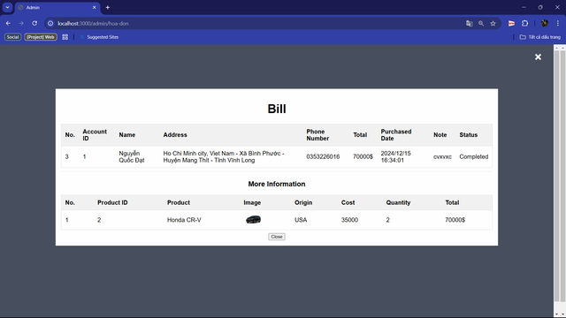

Statistical

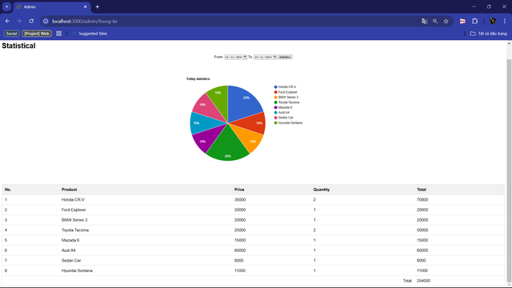

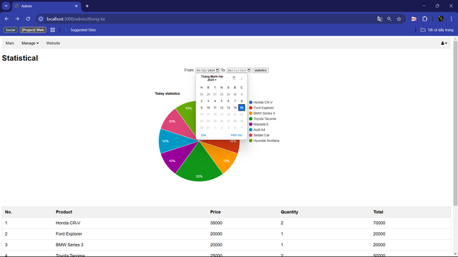

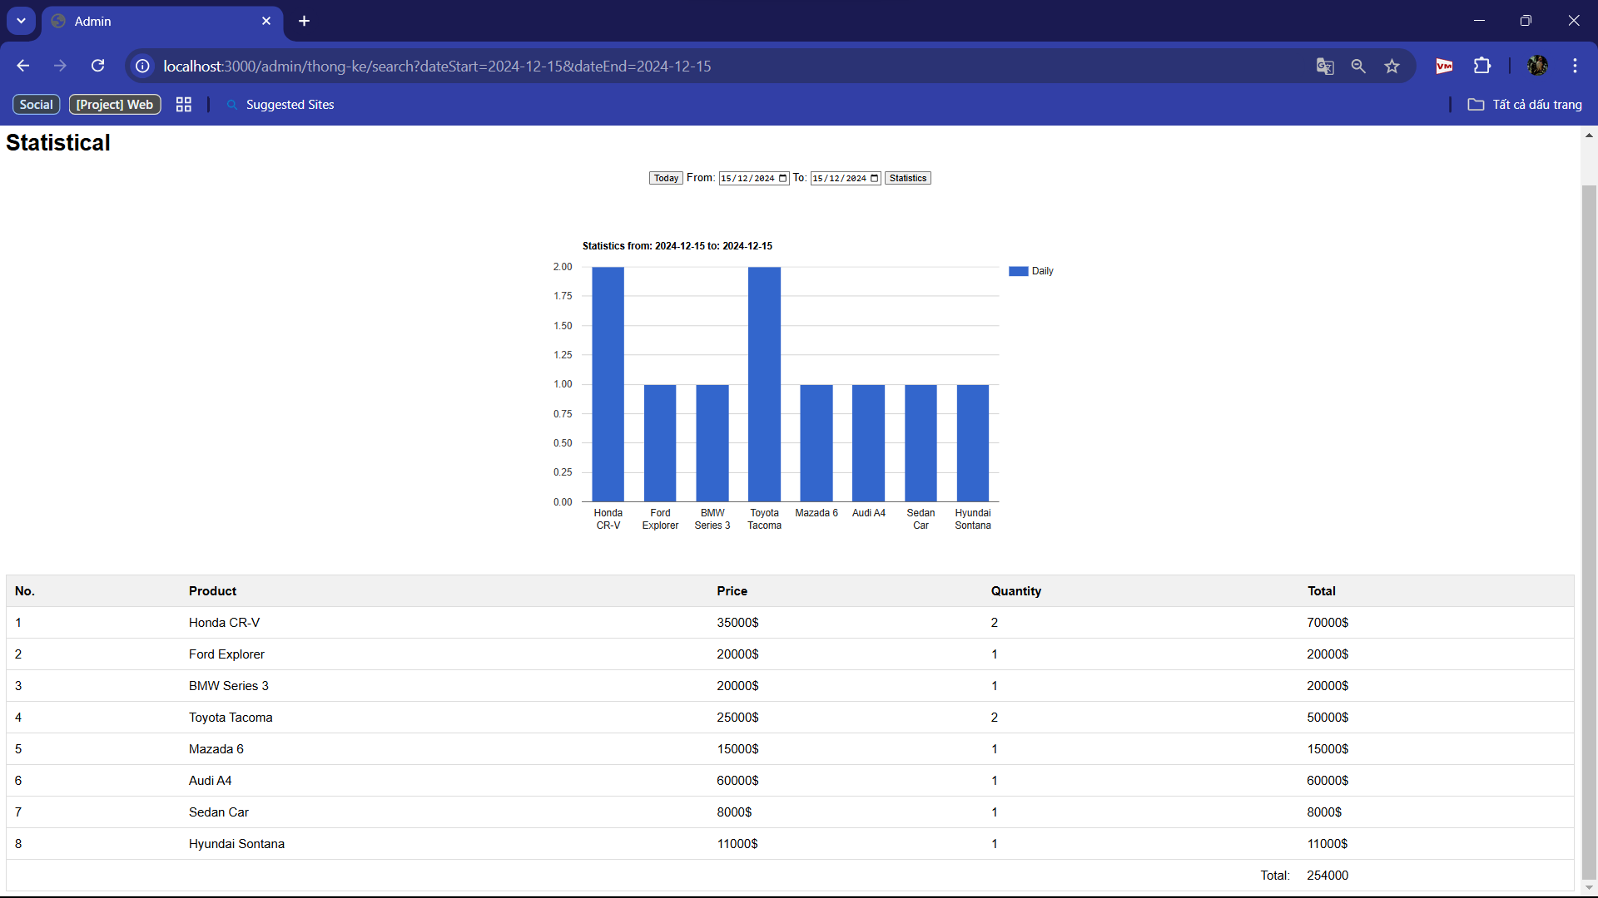

1. **DISCUSSION AND CONCLUSION**

Developing a web application for car sales presented significant challenges, particularly in managing a comprehensive inventory system and implementing a seamless vehicle comparison feature. One of the primary difficulties was efficiently storing and retrieving detailed vehicle data, including images, specifications, and pricing information. Node js and the Ant Design (antd) library provided an excellent foundation for the frontend, enabling a modern, responsive, and user-friendly interface. On the backend, built with Servlets, meticulous optimization was necessary to handle complex queries for filtering and sorting vehicle data. This included configuring Docker containers for improved scalability and leveraging AWS services for secure image storage and fast retrieval. Implementing the vehicle comparison feature added another layer of complexity, requiring precise synchronization between the frontend and backend to ensure accurate and real-time updates to the comparison list, enhancing the overall user experience.

This project was a comprehensive learning experience that helped us gain a better understanding of comprehensive web development and modern deployment techniques. We gained practical knowledge in managing video data, optimizing server performance, and ensuring seamless user interaction. Using the tools to complete the project not only improved our deployment skills but also taught us how to leverage cloud services for scalable applications. Overall, this project strengthened our technical skills and prepared us for future challenges in web development and cloud computing.

1. **REFFERENCES**
2. **FRONT-END**

<https://www.w3schools.com/>

https://vite.dev/guide/

1. **BACK-END**

<https://docs.oracle.com/javaee/7/tutorial/servlets.htm>

<https://www.mysqltutorial.org/>

<https://www.javatpoint.com/example-to-connect-to-the-mysql-database>

<https://dev.mysql.com/doc/>

https://chatgpt.com/